Physiological and subjective responses to indoor greenery: A controlled crossover experiment
Sandra G. L. Persiani^{1*}, Bilge Kobas²
¹Assistant Professorship of Green Technologies in Landscape Architecture, TUM School of Engineering and Design, Technical University of Munich, Munich, Germany
²Chair of Building Technology and Climate Responsive Design, TUM School of Engineering and Design, Technical University of Munich, Munich, Germany
* Correspondence:
Corresponding Author
sandra.persiani@tum.de

Abstract

As people spend most of their time indoors, indoor environmental quality is critical to occupant health, and indoor greenery has been proposed as a contributing component. However, its effects under typical indoor conditions have been examined mainly from perceptual and psychological perspectives, with limited attention to direct physiological responses. This study examines whether indoor greenery influences occupants’ physiological state and subjective experience independently of measurable changes in IEQ, within a controlled, office-like environment. Using a within-subject crossover design, 34 healthy male participants were exposed to four 90-minute conditions: no plants (baseline), real indoor plants, artificial plants (placebo), and real plants located outside a window. Physiological responses related to autonomic activity and stress regulation were continuously monitored, with emphasis on tonic responses. Psychological and experiential outcomes were assessed using standardized instruments and a satisfaction questionnaire. Indoor temperature was controlled, while relative humidity and air quality were continuously monitored. Results show that objective IEQ parameters remained broadly comparable across scenarios, while interiors with real plants were rated more positively and associated with lower and more stable tonic physiological arousal. Artificial plants provided partial perceptual benefits but did not reproduce all effects. Overall, the findings indicate that indoor plants influence occupants through embodied physiological pathways not solely attributable to IEQ changes or cognitive appraisal, highlighting their physiological relevance as interior design elements.

Keywords: Indoor greenery; Physiological response; Placebo ; Indoor environmental quality; Artificial greenery; Crossover experiment; Office environment

- Introduction

Man-made, enclosed environments have become humans’ primary habitat, with people in industrialized societies spending up to 98% of their lives indoors [1]. As a consequence, indoor environmental quality (IEQ) has emerged as a critical determinant of human comfort, performance, and health. On the one hand, remarkable technological and medical advances over just a few generations have enabled societies in the developed world to move beyond primary and secondary necessities, largely securing basic needs related to food, health, and safety. On the other hand, modern artificial environments and lifestyles have been directly associated with a growing range of psychological and physiological effects and diseases [2], a trend that is intensifying as an increasing share of the global population transitions to urban living [3]. Within this context, a growing mismatch has emerged between human biological adaptation to ancestral, natural environments and the rapid transformation of contemporary, man-made settings. In response, the integration of biological elements into buildings - particularly plant life - has been proposed as a strategy to enhance IEQ, with potential benefits spanning environmental quality, mental health, and physical well-being.
The scientific consensus is that indoor greenery contributes to improved indoor air quality [4-7]. Plants have been recognized to potentially absorb pollutants and CO₂ [8, 9] and have been shown to influence indoor relative humidity [10-12], as well as to reduce concentrations of indoor particulate matter [13-15]. The magnitude and relevance of these effects, however, depend strongly on plant species, density, and environmental conditions, including temperature and light availability [16, 17]. Importantly, most evidence derives from controlled and ideal experimental setups [18,19], which may not adequately reflect real-world indoor environments where multiple variables, including human presence and activity, simultaneously influence IEQ. Beyond environmental parameters, indoor plant exposure is associated with reduced stress and depressive symptoms, as shown in epidemiological studies, highlighting the role of indoor greenery in environmental quality [20].

From a psychological perspective, there is broad scientific agreement that the presence of plants enhances positive emotions and reduces negative ones, thereby improving occupants’ mood and perceived comfort. This effect appears consistent across a wide range of approaches, metrics, and dimensions, including mood, satisfaction, emotions, impressions, preferences, attitudes, and comfort [21-24]. However, much of the evidence relies on subjective assessment methods, including self-reported questionnaires and surveys, either custom-designed [11, 22, 25] or standardized, such as the State–Trait Anxiety Inventory or the Zuckerman Inventory of Personal Reactions, to evaluate stress and emotional states [15, 26, 27]. Other approaches adopt indirect measures, recording occupants’ subjective comfort levels and health-related complaints [28]. While valuable, these methods limit the ability to isolate physiological responses from perceptual and cognitive processes.
Productivity is another frequently studied outcome, often grounded in the debatable assumption that high productivity is universally desirable. In this area, findings vary markedly depending on the nature of the task. The presence of plants has been shown to enhance performance in creative and associative tasks [29, 30] and to improve the subjective perception of attentiveness [15, 24]. By contrast, performance in repetitive, low-complexity, and non-creative tasks such as sorting activities may be negatively affected by the presence of plants [29, 30] as well as by their quantity [22]. These outcomes appear highly individual and sensitive to task design, expectation, and contextual bias, limiting their generalizability as IEQ indicators.
In comparison, the physiological effects of indoor plants on humans have received considerably less attention. Existing studies have largely approached these effects from a psychophysiological perspective, interpreting them as physical manifestations of mental states such as emotion, cognition, and behavior [31, 32], or in terms of stress recovery [33]. Direct physiological responses related to autonomic regulation and environmental exposure remain comparatively underexplored. Physiological effects, understood as those related to the normal functioning of the organism and its biological systems, are rarely investigated independently of psychological outcomes [25]. Indeed, the majority of existing studies focus primarily on the visual perception of plants [27, 34-40]. This emphasis overlooks the multisensory nature of human–environment interaction, despite evidence that active engagement with plants, such as touching, gardening, or farming, can produce stronger effects than passive viewing alone [27, 41-43]. Nevertheless, the extent to which indoor plants influence human physiology beyond these established psychophysiological mechanisms remains largely unexplored in occupied indoor settings.
Another recurring theme in the literature on physiological responses to plants is the very short duration of exposure typically examined, as also highlighted by Bringslimark [44]. Electroencephalogram (EEG) studies, in particular, have often focused on intervals of 1–5 minutes [26, 36, 45-48], likely due to the high temporal resolution of EEG data. Similar short time frames have also been used to assess other physiological indicators, such as systolic blood pressure [47] and heart rate variability (HRV) [46]. While these studies report significant changes in brain activity [26] as well as physiological and psychological relaxation responses in the presence of plants, even following very brief exposure [48], the relevance of such transient effects for sustained indoor exposure remains unclear.

Against this background, the primary objective of this experiment was to investigate physiological responses to indoor greenery and to distinguish effects attributable to mental induction from those extending beyond psychophysiological mechanisms reported in previous research. To strengthen causal interpretation, a crossover design was adopted with two comparison conditions: (i) a placebo employing artificial plants, expected to trigger only psychophysiological responses driven by perception, attention, and expectation; and (ii) a control condition in which real plants were visible behind a closed window, allowing exposure to authentic vegetation while restricting interaction to visual cues due to physical separation. The secondary objective was to address a key limitation of existing research by examining physiological responses over a substantially longer exposure period, with participants monitored during 90-minute sessions, yielding 60 minutes of stable, analyzable data. The third objective was to assess whether the presence of indoor plants produces measurable changes in IEQ-related environmental parameters under realistic, occupied indoor conditions. The assessment of long-term health outcomes or clinical effects was beyond the scope of this study, which focuses on immediate physiological responses and environmental effects relevant to indoor environmental quality.

- Experimental design and procedure

A total of 34 test subjects participated in a full-day, within-subject crossover experiment conducted in a controlled climate chamber. Participants were tested individually and remained seated in the chamber during four testing sessions of 90 minutes each, corresponding to four different experimental scenarios. During each session, subjects were asked to perform self-selected, desk-based work tasks, in order to simulate a realistic office-working condition while minimizing task-induced stress.
Between testing sessions, participants took 30-minute breaks outside the climate chamber, during which they exited the building and took a brief walk outdoors. These breaks were intended to reduce carry-over effects and reset physiological and psychological baseline conditions. Before each subsequent session, subjects underwent an acclimatization period of 15–30 minutes inside the indoor space prior to data collection.
During the absence of the participant, the experimental setting was reconfigured according to a pre-assigned randomized testing sequence.

  - Experimental scenarios and randomisation
Four experimental scenarios were defined (Figure 1). Each participant was randomly assigned a unique sequence of the same four scenarios, following a crossover design to account for order and carry-over effects (Table 1).
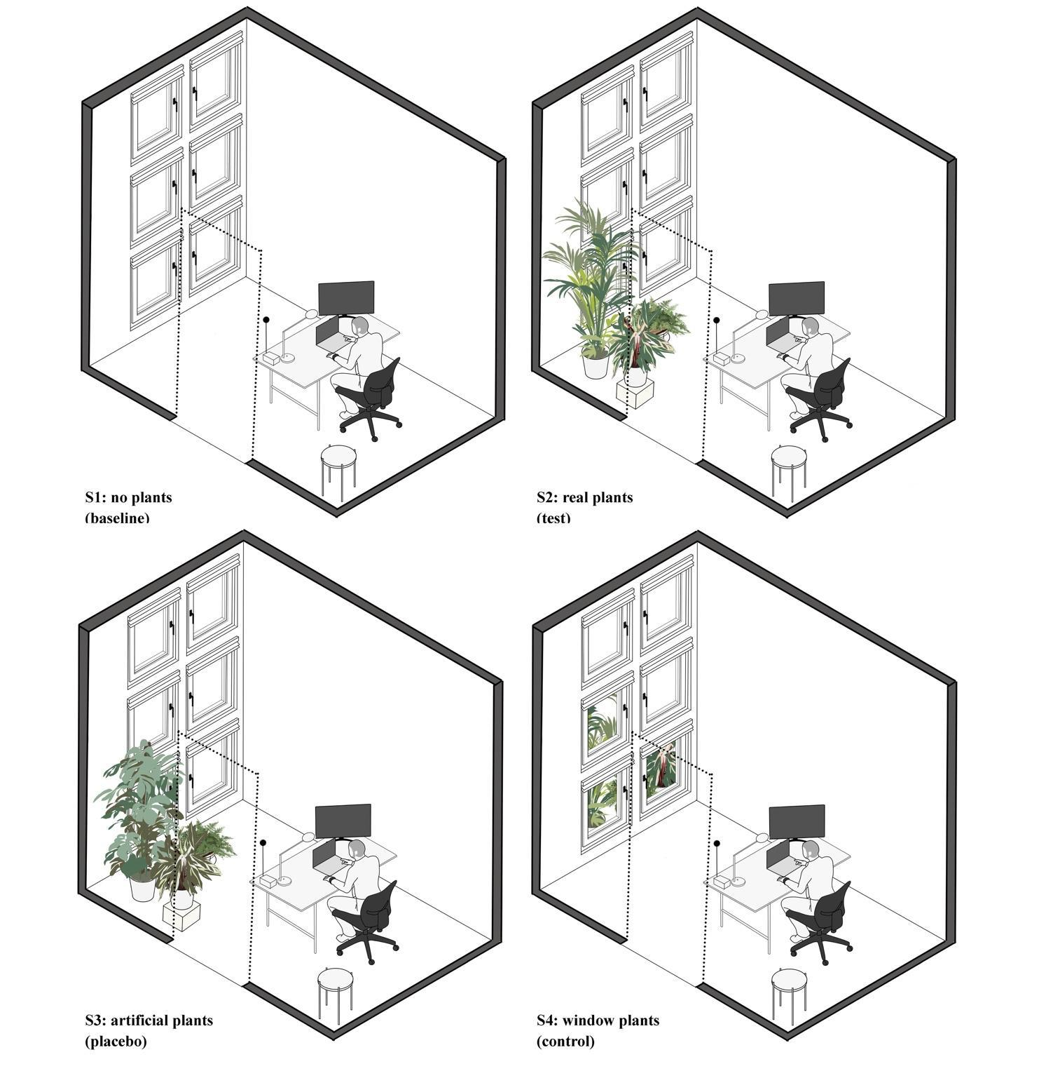
Figure 1 – Room layout for Scenarios 1–4.

Scenario 1: No plants. Baseline condition. The room (4.0 × 2.5 m, height 2.75 m) was configured to resemble a typical office workspace, including a desk, chair, computer screen, keyboard, mouse, and adjustable artificial lighting, as well as natural daylight from a large window overlooking an inner courtyard. No plants were present in the room (Figure 1).
Scenario 2: Real green plants. Intervention. In this scenario, three potted living plants were introduced into the room, which otherwise remained identical to Scenario 1 (Figure 1). Plant species were selected from commonly used office plants and combined different heights to maximize visible greenery while allowing efficient relocation between scenarios. The selected species were Howea fosteriana (170 cm), Calathea triostar (60 cm), and Davallia fejeensis (55 cm width) (Figure 2).
The plants were not repotted prior to testing and retained their original growing substrate. To minimize direct effects on relative humidity, watering was performed only after the completion of each testing day and outside the experimental sessions.

Figure 2 – Plants used in the experiment: real plants in Scenarios 2 and 4 (left) and artificial plants in Scenario 3 (right).

Scenario 3: Artificial plants. Visual placebo. This scenario was designed to replicate the appearance of Scenario 2 while eliminating biological activity (Figures 1 and 2). Due to the difficulty of sourcing visually identical real and artificial specimens, different plant species were selected to achieve effective blinding. Artificial plants included Monstera deliciosa (150 cm), Calathea triostar (50 cm), and Polystichum munitum (70 cm width). Plants were mounted in real mineral substrate (Vulkastrat) to enhance visual realism.
Scenario 4: Real green plants outside the window. Visual control. The same living plants used in Scenario 2 were placed outside the window, remaining visible from the interior (Figure 1). Scenario 4 controls for visual exposure to greenery while excluding direct physical interaction, allowing comparison with both the baseline (S1) and the full-interaction condition (S2).

  - Test subjects
Given the exploratory nature of the study, the limited sample size, and the sensitivity of autonomic and thermophysiological measures to sex-related physiological variation, recruitment was restricted to male participants. This design choice improved internal consistency but limits generalisability. Thirty-four healthy males aged 20–40 years, with diverse ethnic backgrounds, were recruited among university staff and students through flyers and direct contact (Figure 3). One participant identified as a smoker but agreed to refrain from smoking during the testing day and reported no withdrawal symptoms. No participants with known chronic illnesses were included.

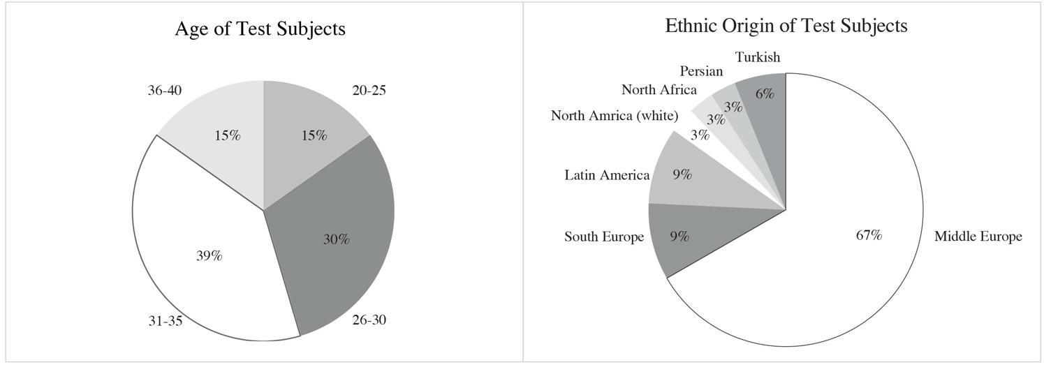
Figure 3 – Participant demographics: age distribution (left) and self-reported ethnic origin (right).

  - Measurements and indoor environmental conditions
Physiological data were continuously recorded using a biometric wristband (Empatica E4) worn on the non-dominant hand. Recorded parameters included electrodermal activity (EDA), skin temperature, acceleration (movement), and blood volume pulse (BVP), from which heart rate–related features were derived. To minimize confounding influences on cardiovascular and autonomic measures, participants were asked to avoid coffee, tea or any other energizing beverages for at least one hour before the first session. Before each session, subjects remained seated for 15 minutes to stabilize physiological parameters.
Psychological and performance assessments were administered at the end of each session, including PANAS-GEN, a non-standardized satisfaction questionnaire (7-point Likert scale), and a 64-card Wisconsin Card Sorting Test (WCST).
Indoor environmental conditions were kept as stable as possible. Air temperature was maintained at 22 °C, while relative humidity and air quality were measured but not actively controlled. Acoustic conditions were not measured. Lighting conditions were intentionally allowed to vary, reflecting realistic daytime conditions through a combination of daylight and artificial lighting. Outdoor light levels were relatively low due to the testing period (December–March, latitude 48°08′N). Air quality was monitored using an airQ sensor placed adjacent to the participant.
As a comparison with existing literature, the Index of Greenness (IG) was calculated following Choi et al. [46], based on photographs taken from the seated eye-level position (1.30 m height). Scenarios S2 and S3 resulted in approximately 7% visual green coverage, comparable to previously reported moderate greenery conditions [22].

  - Data processing and analysis
All physiological and environmental data were synchronized into a continuous time-series dataset. Skin temperature data were smoothed using a 5-minute rolling window with 1-minute overlap. EDA signals were processed using neurokit2, decomposed into phasic and tonic components; tonic EDA was used for analysis. BVP data were processed using a heartyPy library in Python, applying a Butterworth filter with bandpass cutoffs (beyond the 0.75–3.5 Hz range). A 4-minute moving window with 30-second overlap was used to smooth data before further feature extraction was performed. The resulting raw data resolution was 4Hz for EDA, and 64Hz for skin temperature and BVP.
All signals were downsampled to a 1-minute resolution and aligned temporally. Data collected during breaks were excluded. For physiological data, the first 15 minutes and final 30 minutes of each session were removed to avoid artifacts related to entry and exit events. All variables were normalized per participant using Z-score transformation to account for inter-individual variability.
Two complementary analytical approaches were used: (i) delta time-series analysis, aligned at a common starting point to evaluate temporal trends; and (ii) distribution-based analysis using boxplots, displaying absolute values over the full session duration. Statistical significance was assessed using pairwise t-tests, with thresholds of p < 0.05 (significant), p < 0.01 (highly significant), and p < 0.001 (extremely significant).
In contrast to the physiological and environmental measurements, subjective data derived from questionnaires and performance tests were not time-matched to the continuous time-series dataset. These measures were treated as session-level outcomes and analyzed independently. Their inclusion was intended primarily to enable comparison with existing literature, which predominantly relies on subjective and post-exposure assessments of comfort, affect, and performance. Accordingly, subjective results were used to contextualize and verify the direction of observed physiological trends, rather than to establish direct temporal correlations between perceived and physiological responses.
Data from five participants was excluded from physiological and psychological analyses due to failure of placebo blinding in Scenario 3 (Table 1). Environmental data from all sessions were retained.

- Results

  - Indoor environment
Indoor environmental measurements exhibited largely comparable temporal trends across all four experimental scenarios, with only minor differences observed between conditions. Overall, the results indicate that the presence of indoor greenery did not substantially alter the monitored IEQ parameters under the tested conditions.
Oxygen (O₂) levels progressively decreased over the course of each testing session, while carbon dioxide (CO₂) concentrations increased (Fig. 4), as expected due to occupant presence and metabolic activity in a closed indoor space. Although CO₂ concentrations increased at a slightly faster rate in Scenario 2 (real indoor plants) compared to scenarios without living plants inside the room, the absolute differences between scenarios remained small and within comparable ranges, suggesting no meaningful mitigation of CO₂ accumulation attributable to plant presence at the tested scale and light conditions. Boxplot analysis confirms the observations: median O₂ values are nearly identical across scenarios (≈20.86–20.87), with strongly overlapping interquartile ranges and limited variability. Similarly, CO₂ distributions show substantial overlap among scenarios, with comparable median concentrations and broad but similar spreads. Overall, the presence of real plants did not result in a measurable difference in average indoor O₂ or CO₂ levels during the experimental timeframe.
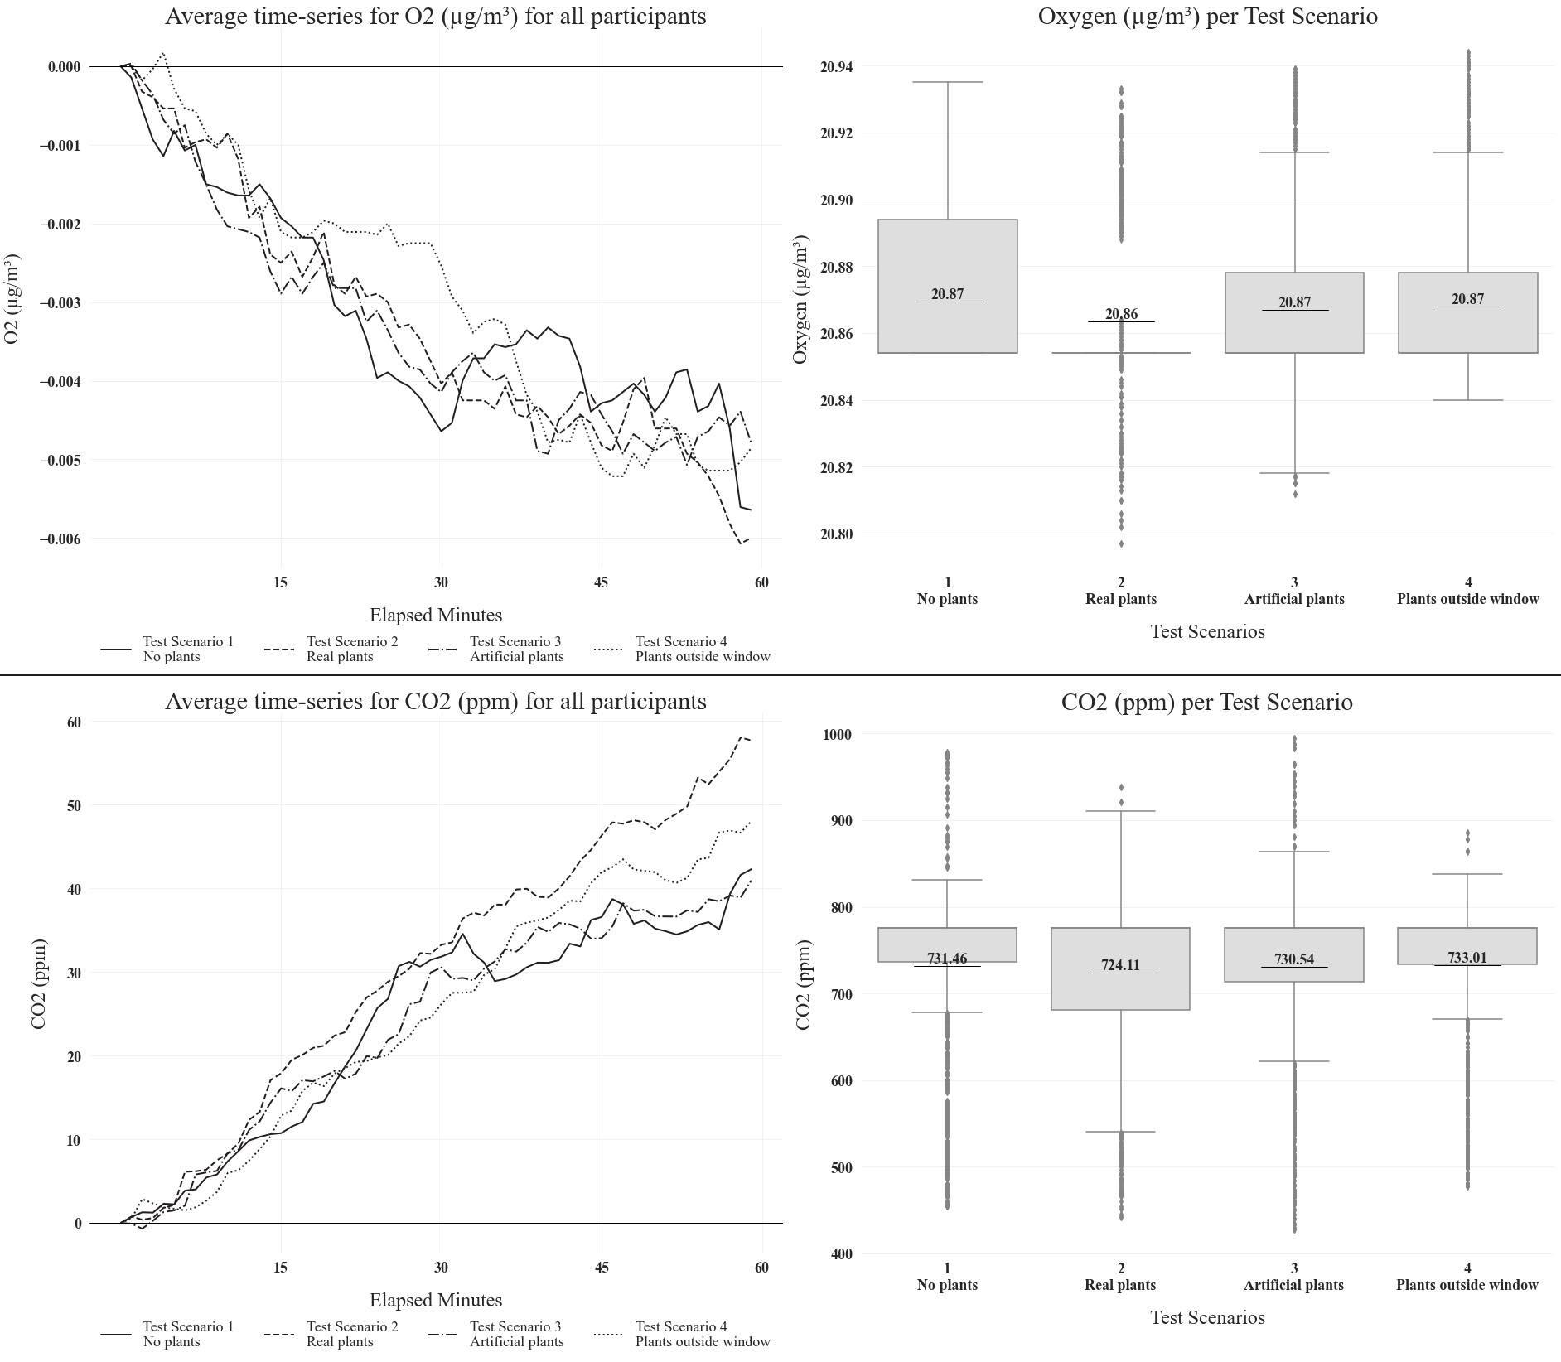
Figure 4 – Average indoor O₂ (µg/m³) levels and CO₂ (ppm) concentrations across the four scenarios, presented as temporal trends (time series Δ, left, aligned to a common starting point) and boxplots (right).

Indoor relative humidity (RH) increased progressively over the 60-minute monitoring period across all scenarios, as shown by the time-series data (Fig. 5). While the overall pattern is similar, the boxplots show slightly higher median relative humidity (≈33.7%) in the real plants condition , whereas the no-plants, artificial plants, and plants-outside-the-window scenarios show slightly lower but comparable median values (≈33.1–33.3%). Despite these differences, the interquartile ranges overlap substantially across all scenarios, indicating moderate variability and relatively small absolute differences in average RH, indicating that changes in RH were primarily driven by occupant-related moisture release rather than by the presence or absence of plants.
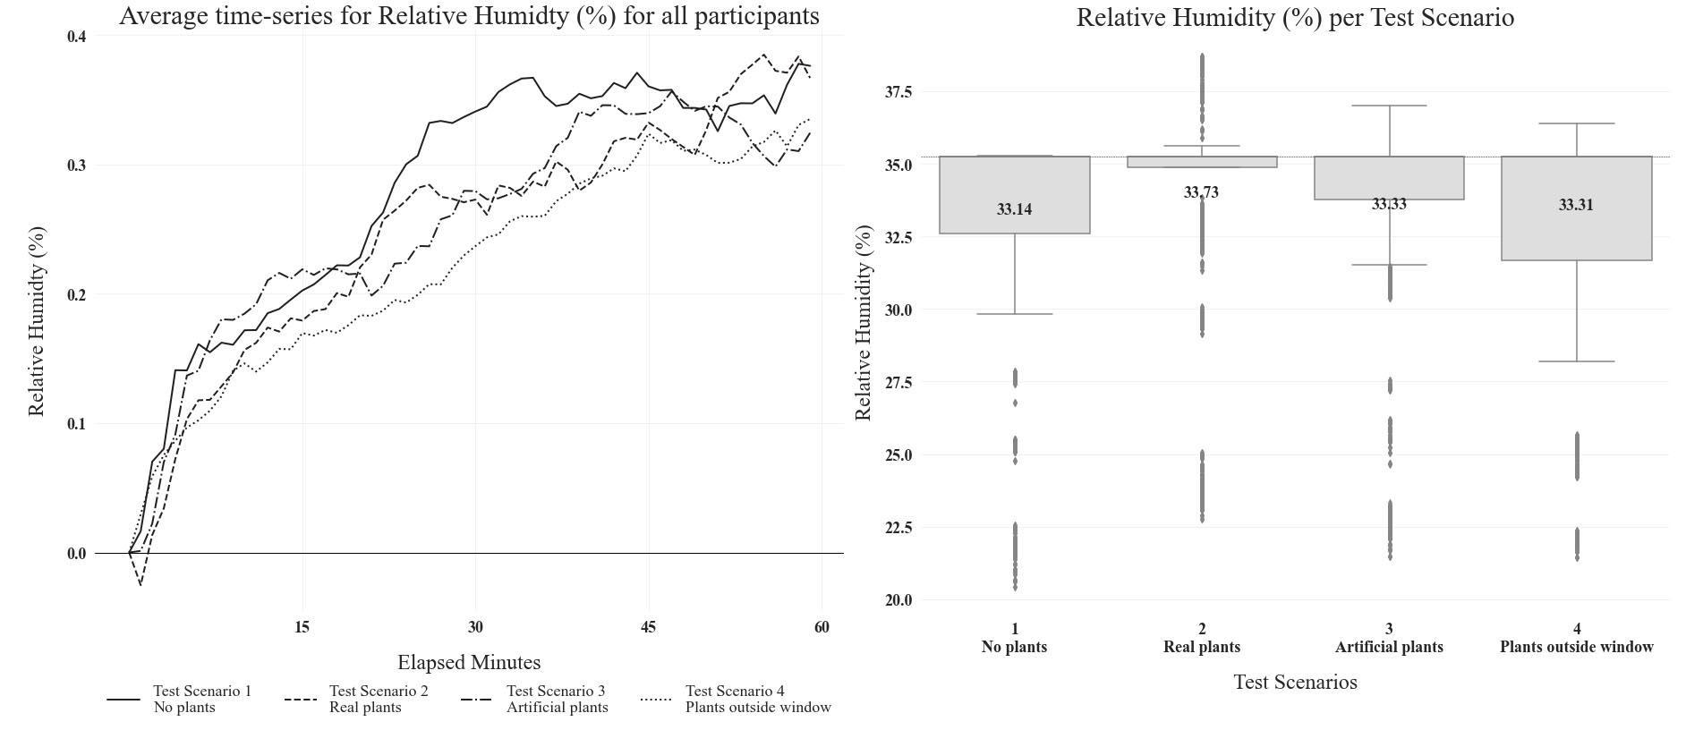
Figure 5 – Average indoor Relative Humidity (%) across the four scenarios, presented as temporal trends (time series Δ, left, aligned to a common starting point) and boxplots (right).

Indoor ozone (O₃) concentrations exhibited a brief initial increase during the first 10-15 minutes in all scenarios, followed by a gradual decline over the measurement period (Fig. 6). The no-plants scenario showed the most rapid and pronounced decrease, resulting in the lowest O₃ levels by the end of the experiment. In contrast, the presence of real plants, artificial plants, and plants located outside the window was associated with a slower reduction in O₃, with the artificial-plants scenario maintaining the highest concentrations over time. Boxplot analysis showed similar median O₃ concentrations across scenarios (≈10–11 µg/m³), although the real-plants condition displayed the highest median (11.17 µg/m³) and the greatest variability.

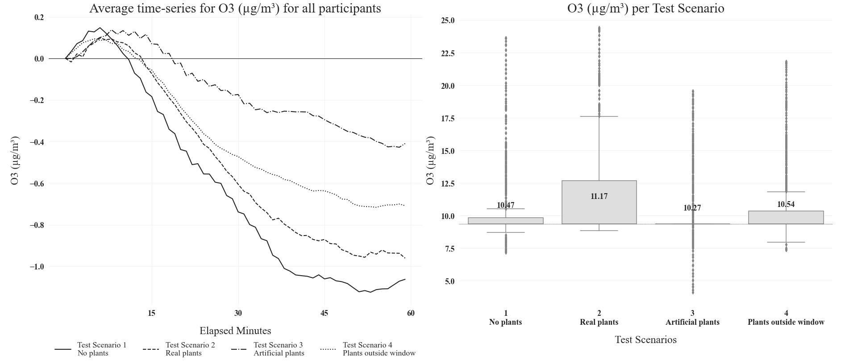
Figure 6 – Average indoor O₃ (µg/m³) across the four scenarios, presented as temporal trends (time series Δ, left, aligned to a common starting point) and boxplots (right).

Across all particle size fractions (PM₁, PM₂.₅, and PM₁₀), the time-series data show pronounced short-term fluctuations around relatively low average concentrations, with no clear increase or decrease over the 60-minute period (Fig. 7). These oscillations are evident in all four scenarios and suggest that indoor particulate levels are dominated by transient events rather than by steady accumulation or removal processes. The boxplots show that median concentrations are similar across all scenarios for each particle size (PM₁.₀ ≈ 1.9–2.2 µg/m³, PM₂.₅ ≈ 2.4–2.8 µg/m³, PM₁₀ ≈ 2.7–3.1 µg/m³). While median PM levels under the real plants condition remain comparable to the baseline, the consistently wider interquartile ranges indicate greater variability across all PM fractions. Overall, interquartile ranges overlap substantially between scenarios, and the distributions are broad, with numerous high-value outliers.

Taken together, these results confirm that IEQ parameters remained broadly comparable across scenarios, allowing subsequent analyses to interpret physiological responses with minimal confounding from environmental variability.
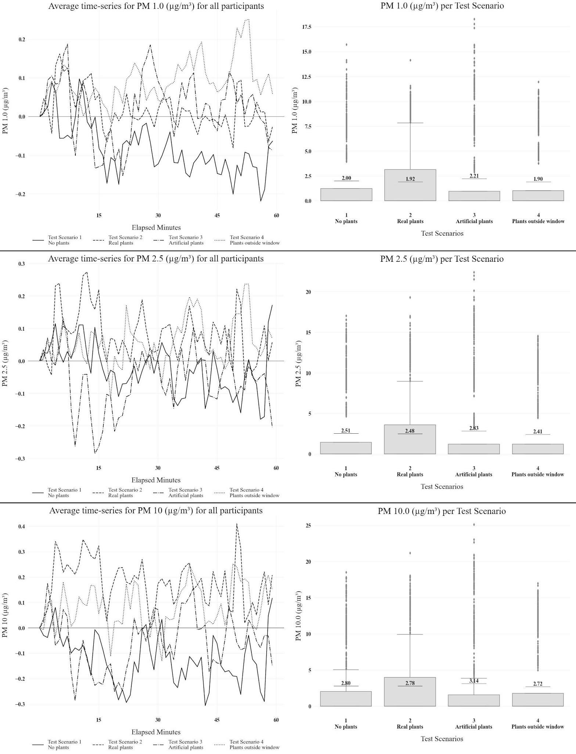
Figure 7 – Average indoor PM concentrations (µg/m³) (PM 1, 2.5 and 10) across the four scenarios, presented as temporal trends (time series Δ, left, aligned to a common starting point) and boxplots (right).

  - Physiological responses

Physiological responses were analysed with a focus on autonomic nervous system activity, in line with the study’s aim of identifying direct physiological effects under controlled indoor conditions. Phasic electrodermal activity (EDA), reflecting transient event-related responses, was not considered central due to the absence of abrupt stimuli and is therefore not discussed further. The analysis focused on tonic EDA as an indicator of sustained autonomic arousal. Time-series data for average tonic EDA (z-scores), reflecting baseline arousal, reveal distinct temporal patterns across the four scenarios (Fig. 8). Conditions without indoor greenery (no-plants and plants-outside-the-window) show a gradual increase in tonic EDA over time, particularly in the second half of the session, indicating rising sustained autonomic activation. In contrast, indoor plant conditions are associated with attenuated responses. The real plants scenario remains consistently lower and more stable around baseline, whereas the artificial plants scenario shows higher levels and a moderate increase over time. The boxplots support these trends, showing small but meaningful differences in tonic EDA. Median tonic EDA is lowest with real plants (≈ −0.30 z) and highest with artificial plants (≈ 0.32 z), while the no-plants and plants-outside-the-window scenarios fall in between (≈ 0.04 z and ≈ −0.06 z), despite substantial variability and overlapping distributions.

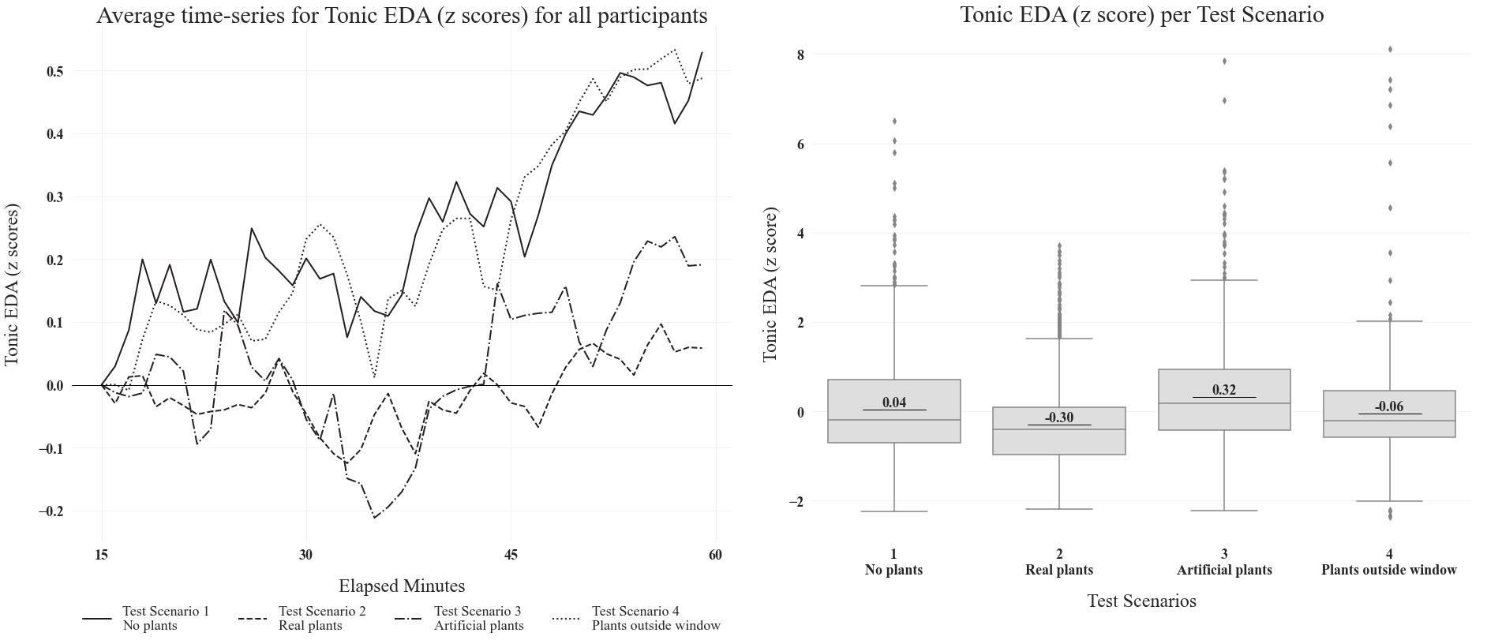
Figure 8 – Average tonic EDA across participants, presented as temporal trends (time series Δ, left, aligned to a common starting point) and boxplots (right).

To assess autonomic cardiac responses, heart rate (HR), the high-frequency (hf) component of heart rate variability, and the LF/(LF+HF) ratio were analysed as indicators of physiological activation, parasympathetic modulation, and sympathovagal balance (Fig. 9). These measures mainly reflected short-term autonomic fluctuations, with time-series data showing high variability around baseline and no clear trends across scenarios. The boxplots confirmed substantial overlap and minimal differences between conditions, indicating that HR-based metrics were less sensitive than tonic EDA to sustained environmental effects.

Figure 9 – Average Heart Rate (HR), heart frequency (hf) and average lf/lf+hf presented as temporal trends (time series Δ, left, aligned to a common starting point) and boxplots (right).

Skin temperature at the extremities is commonly used as an indicator of stress regulation, as peripheral vasodilation and increased skin temperature counteract sympathetic stress responses [49]. In this experiment, time-series data show a progressive increase in skin temperature across all scenarios, indicating a general warming trend over time (Fig. 10). However, the magnitude and rate of increase differ between conditions. Scenarios without plants inside the room (no-plants and plants-outside-the-window) show the steepest rises and highest final values, whereas the real plants scenario exhibits a slower, more attenuated increase. The artificial plants condition follows an intermediate pattern, with an initial rise followed by stabilization or slight decline. The boxplots support these trends, with similar median skin temperatures for real (≈0.12 z) and artificial plants (≈0.11 z), and lower medians for the no-plants (≈0.04 z) and plants-outside-the-window (≈–0.26 z) scenarios.

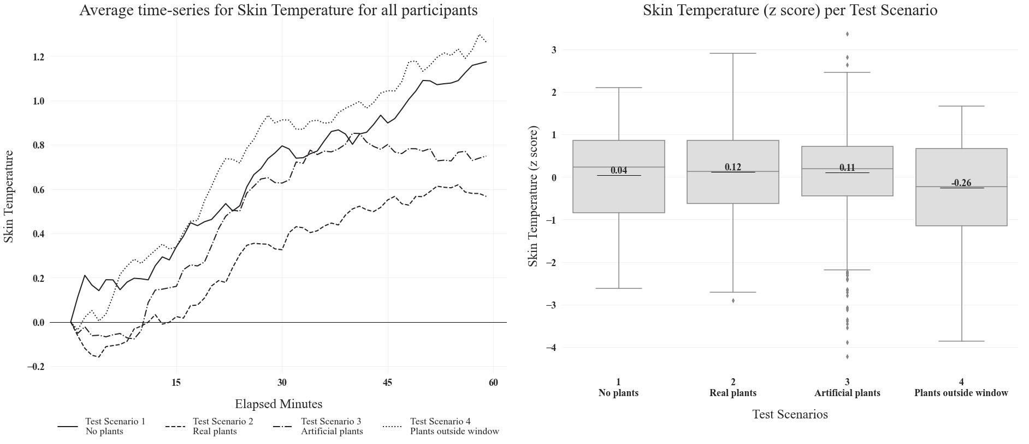
Figure 10 – Average Skin Temperature (°C) presented as temporal trends (time series Δ, left, aligned to a common starting point) and boxplots (right).

  - Psychological responses and attention

The Wisconsin Card Sorting Test (WCST) is a widely used neuropsychological task assessing executive functions, particularly cognitive flexibility (set shifting), attention, and abstract reasoning [50,51]. Cognitive flexibility refers to the ability to adapt behaviour by switching between rules or tasks and is a demanding executive function that relies on working memory and inhibitory control [52]. A key WCST outcome is perseveration errors, which reflect persistence in incorrect response patterns despite feedback; higher error rates indicate reduced cognitive flexibility and difficulty disengaging from previously learned rules [53]. Boxplots of WCST perseveration errors (z-scores) show broadly similar cognitive performance across scenarios, with medians near zero and substantial overlap in variability (Fig. 11). Slightly lower median error rates are observed in the artificial (≈ –0.15 z) and real plants (≈ –0.06 z) conditions, while marginally higher values occur in the no-plants (≈ 0.05 z) and plants-outside-the-window (≈ 0.16 z) scenarios. However, wide interquartile ranges indicate considerable inter-individual variability, suggesting that any cognitive benefits of plant presence are modest and secondary to individual differences.
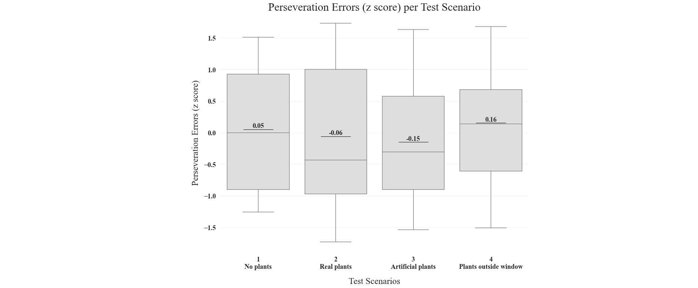
Figure 11 – Average perseveration errors across the four scenarios, presented as boxplots.

The questionnaire primarily assessed participants’ subjective appreciation of the room, without explicitly referring to plants or otherwise drawing attention to their presence. Boxplots of the aesthetic evaluations show clear and consistent differences across scenarios for all dimensions (Interiors, Layout, Comfort, and Size Perception) (Fig. 12). The no-plants condition is associated with the lowest median scores across all categories, indicating poorer aesthetic and spatial appraisal. In contrast, both real and artificial plants yield higher median scores, particularly for Interiors and Layout, suggesting that the presence of greenery, regardless of its biological nature, enhances perceived visual quality and spatial organisation. The plants-outside-the-window condition occupies an intermediate position, indicating that indirect visual access to vegetation is less effective than plants placed within the interior. More specifically, the strongest positive shifts are observed for Interiors and Layout in the real and artificial plants scenarios, while Comfort scores follow a similar pattern, with slightly positive medians for interior plants and negative medians for the no-plants and outside-plants conditions. Size Perception shows the largest contrast, with a distinctly positive median in the real plants scenario and a markedly negative median in the no-plants condition. These aesthetic findings are reinforced by results from the questions on subjective physical comfort (Fig. 13). While perceived thermal comfort remains broadly comparable across scenarios, perceived air quality is highest in the real plants condition and slightly negative or neutral in all others, despite similar objective IEQ measurements. Overall, the results indicate that indoor plants, especially real ones, enhance aesthetic appreciation and perceived air quality without producing substantial changes in measured environmental parameters.
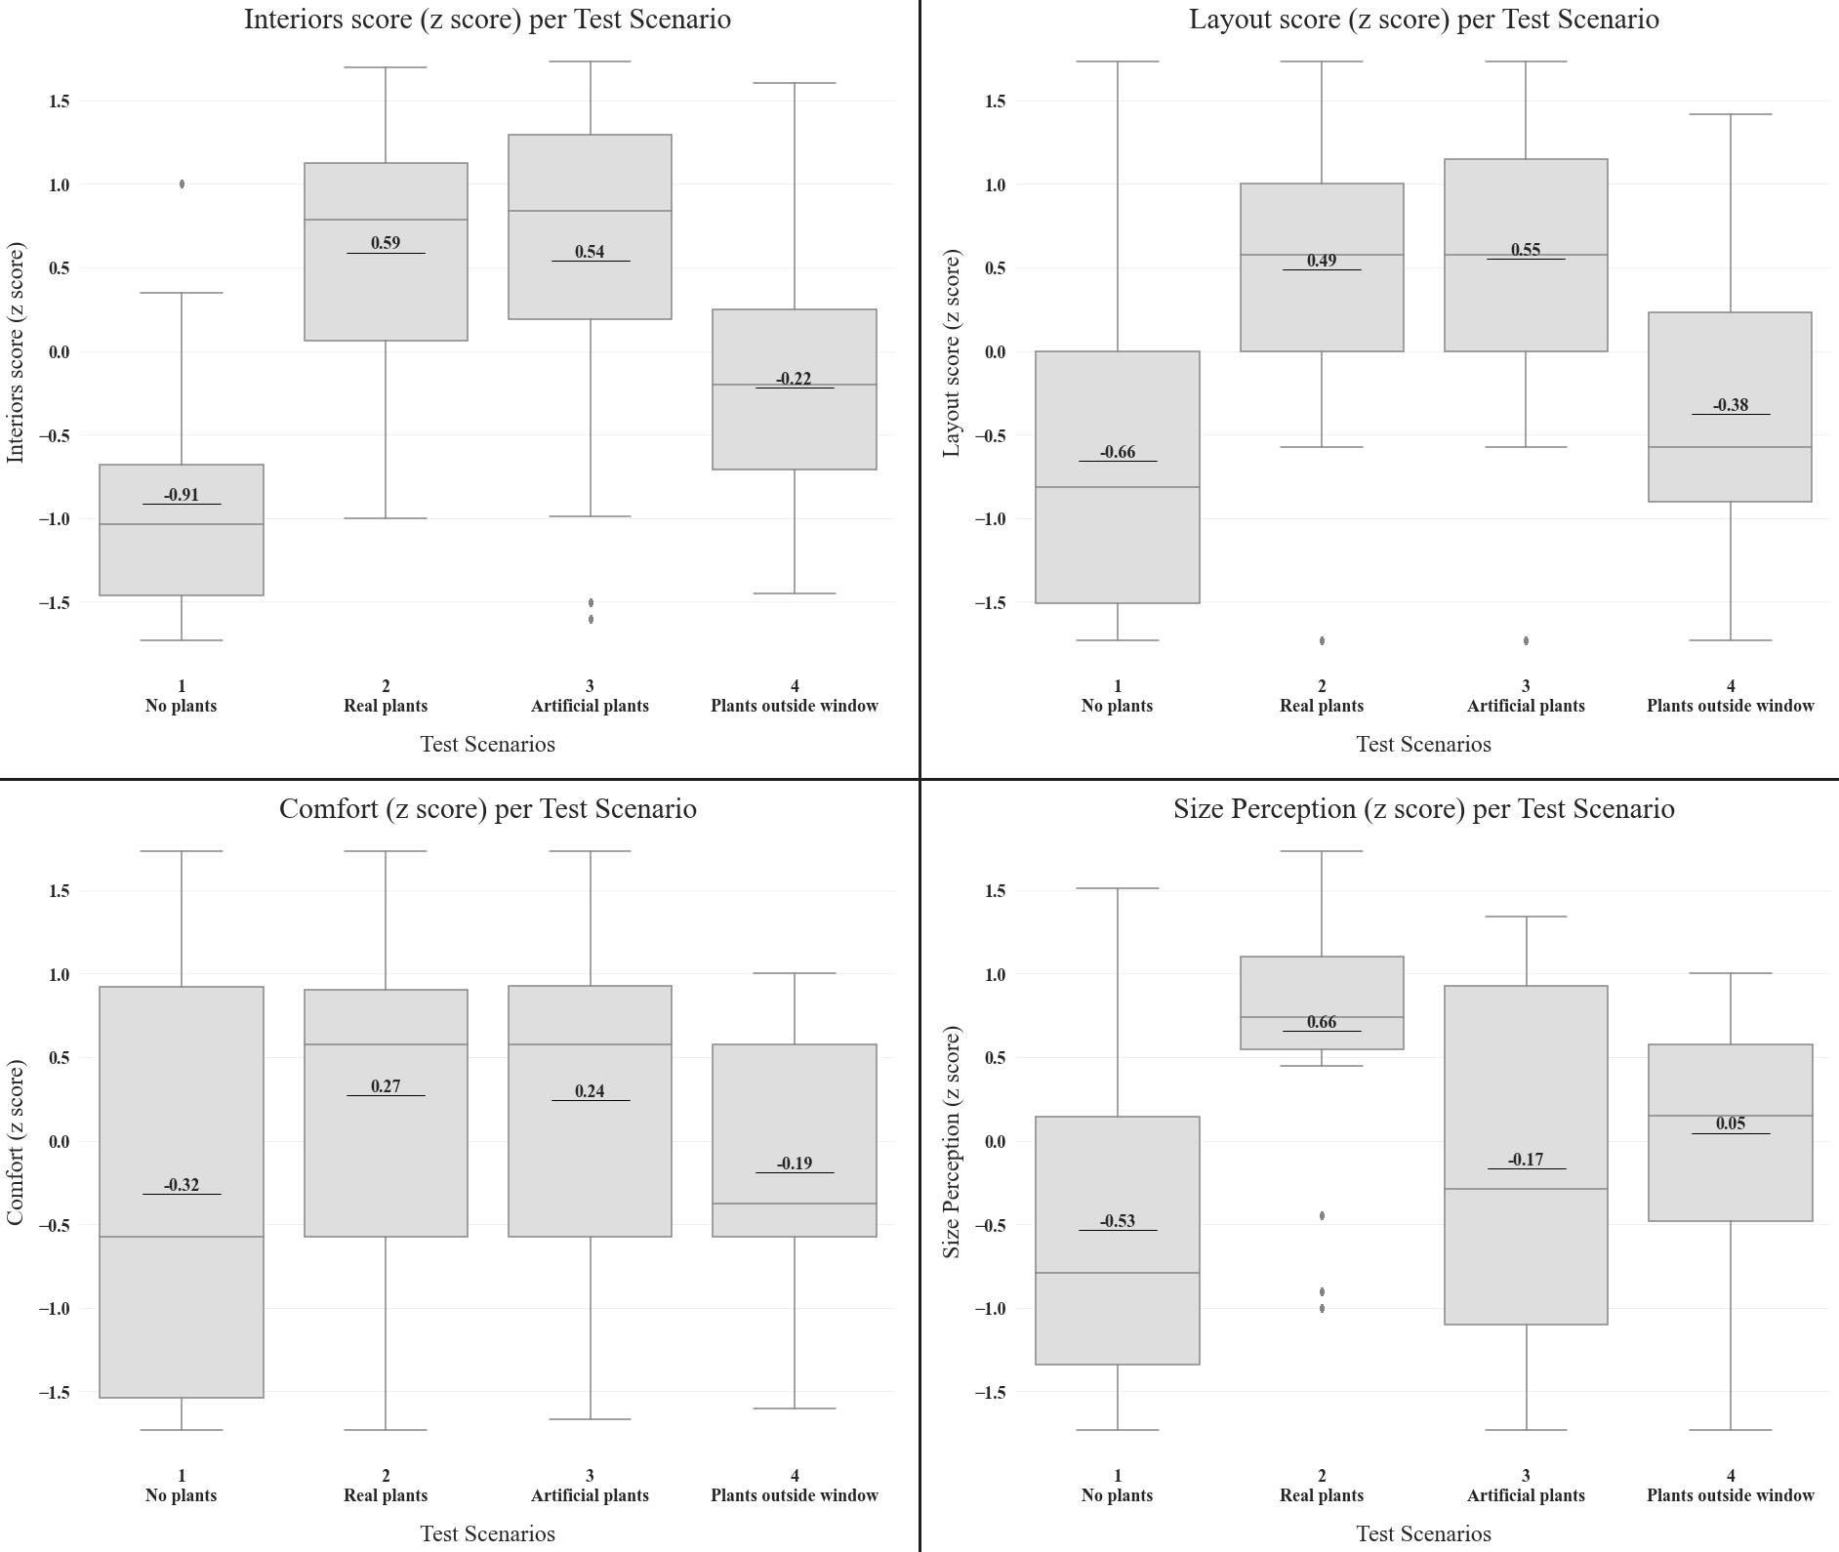
Figure 12 – Average appreciation of the aesthetic qualities of the indoor environment across the four scenarios, presented as boxplots.

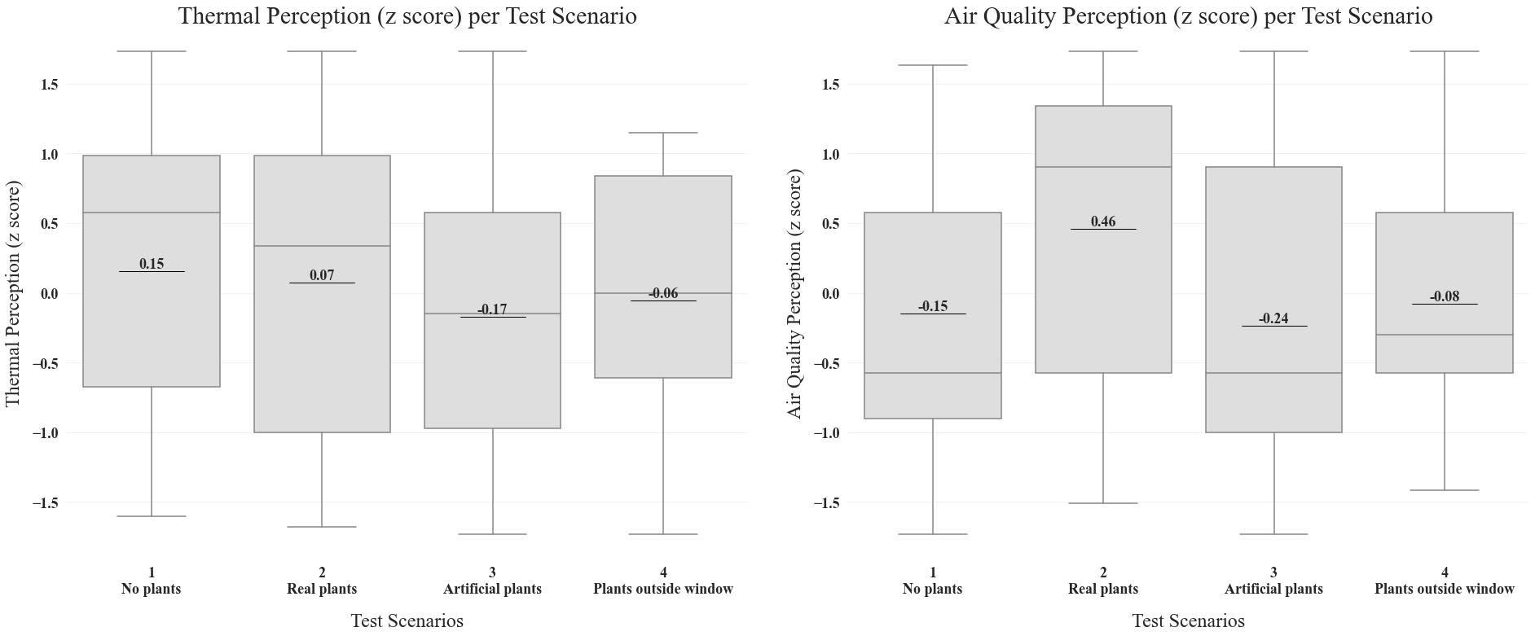
Figure 13 – Average perceived physical comfort qualities of the indoor environment (subjective thermal and air quality perception) across the four scenarios, presented as boxplots.

The PANAS-GEN is a widely used and reliable measure of affect - emotional states that influence behaviour and decision-making - in both clinical and non-clinical settings [54,55]. Positive and negative affect (PA and NA) are independent dimensions that support motivation through different mechanisms: PA is associated with intrinsically rewarding experiences and flexible thinking, whereas NA is linked to increased effort and focused, performance-oriented processing [22, 46, 47].
Boxplot analysis (Fig. 14) shows clear scenario-dependent differences in affective responses (Fig. 15). Positive affect is highest in the real plants condition (median ≈ 0.26 z), near neutral with artificial plants (≈ –0.02), and lower in the no-plants and plants-outside-the-window scenarios (≈ –0.09 and ≈ –0.15). Negative affect is highest without plants (≈ 0.45), while real plants remain near neutral (≈ 0.02) and artificial plants and plants-outside-the-window show reduced negative affect (≈ –0.26 and ≈ –0.21).

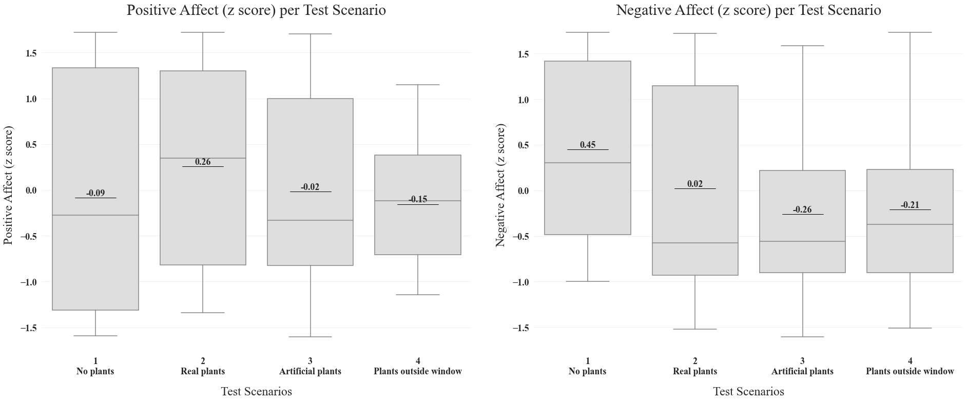
Figure 14 – Average positive and negative affect (PANAS GEN) across the four scenarios, presented as boxplots.

- Discussion

  - IEQ outcomes under plant-present conditions

Across all scenarios, objective indoor environmental quality (IEQ) parameters, including O₂, CO₂, particulate matter (PM₁, PM₂.₅, PM₁₀), ozone, relative humidity, and temperature, remained broadly comparable, with no systematic differences attributable to the presence or absence of plants. Minor scenario-dependent variations, particularly for relative humidity and ozone, were small relative to overall temporal and inter-individual variability. This confirms that the experimental conditions were well controlled and that observed physiological, perceptual, and affective differences cannot be attributed to confounding changes in indoor environmental conditions. The results indicate that indoor plants, as typically implemented in occupied spaces, do not function as effective regulators of indoor air chemistry or thermal conditions. With relatively low plant densities and conventional ornamental species, biological processes such as photosynthesis, transpiration, and pollutant uptake are negligible compared to dominant drivers of IEQ, including human metabolism, ventilation, and outdoor air exchange. While higher plant densities or specialized systems may yield different outcomes, such configurations fall outside typical indoor applications.
O₂ and CO₂ measurements showed no detectable effect of the plants on oxygen enrichment or carbon dioxide reduction in the tested spaces over short time scales. Observed decreases in O₂ and increases in CO₂ were driven primarily by human respiration and limited air exchange, which outweighed the photosynthetic capacity of the plants used. This aligns with building-science and physiological literature indicating that occupant metabolism dominates indoor gas exchange under typical conditions [58]. By contrast, controlled experiments have reported substantial plant-related CO₂ uptake, with reductions of ~10–20% in species such as Sansevieria trifasciata and Spathiphyllum kochii [59, 60] and >60–75% in Syngonium podophyllum and Ficus benjamina under high-density or hydroculture conditions [19, 61]. These differences reflect strong context and scale effects. Such studies typically rely on small, sealed chambers, high plant-to-volume ratios (≈0.31–1 m² leaf area per m³ of air), and optimised lighting and environmental conditions [19, 60], which differ markedly from real occupied interiors. Consistently, no significant associations between indoor plants and CO₂ concentrations have been observed under realistic experimental conditions [62]. Although plants can theoretically stabilise O₂ levels when illuminated above their light compensation point [63, 64], such conditions are rarely achieved in everyday indoor environments without dedicated lighting systems [65].
Indoor relative humidity (RH) was driven mainly by occupancy and exposure time, with moisture from human respiration and activity accounting for the overall increase across scenarios. Real plants were associated with slightly higher RH, consistent with transpiration, but the effect was small and secondary to dominant indoor moisture sources. The discrepancy with studies reporting RH increases up to 80% in planted indoor environments [10-12] can be explained by differences in scale and context, as such effects are typically observed under controlled conditions, high plant densities, or limited ventilation. In this more realistic architectural setting, plant transpiration was insufficient to produce substantial or sustained RH changes. From an indoor environmental quality and architectural perspective, the findings indicate that indoor plants may provide minor, localized humidity buffering but cannot replace ventilation and mechanical systems as primary means of RH control.
O₃ concentrations decreased over time across all scenarios, reflecting ozone’s high reactivity and rapid removal through surface deposition and indoor chemical reactions. This decay is consistent with established indoor air chemistry, whereby ozone is efficiently scavenged by building materials, furnishings, and interior surfaces. Small scenario-dependent differences were observed, suggesting that interior surface characteristics, including vegetation, may influence ozone dynamics to a limited extent. The no-plants scenario showed a slightly faster decline, while plant-present conditions, particularly with real plants, exhibited marginally higher average concentrations. However, the strong overlap between distributions indicates that these differences are modest and should be interpreted cautiously. These findings partially contrast with experimental studies reporting ozone reduction attributable to indoor plants. For example, Papinchak et al. [66] observed lower indoor O₃ levels with plants present, and Abbass et al. [67] reported removal efficiencies of ~0.9–9% under specific plant density and lighting conditions. The discrepancy likely reflects differences in plant species, density, lighting, and exposure duration, as well as the low and rapidly decaying ozone concentrations typical of occupied indoor environments. Moreover, ozone–plant interactions are complex and species-dependent, influenced by stomatal conductance, leaf traits, and surface moisture [68, 69]. Plants may also indirectly influence ozone chemistry through the emission of biogenic volatile organic compounds (VOCs), such as isoprene, which can participate in ozone formation under specific chemical and climatic conditions [69, 70]. While such processes are primarily relevant at urban or outdoor scales, they highlight the bidirectional and context-dependent role of vegetation in ozone dynamics. In indoor environments, where light levels, oxidant availability, and air exchange rates are limited, these mechanisms are likely to be strongly attenuated, further reducing the net influence of plants on indoor ozone concentrations.
For particulate matter (PM), the results show no systematic reduction in PM₁, PM₂.₅, or PM₁₀ associated with plant presence. Instead, PM concentrations were dominated by high temporal variability driven by short-term disturbances such as occupant movement, surface resuspension, and outdoor infiltration. While real plants did not reduce overall PM levels, they may have influenced temporal patterns, contributing to less uniform PM concentrations over time rather than to sustained removal. These findings are consistent with broader environmental research showing that vegetation can contribute substantially to PM removal at the urban scale [70], but that its effectiveness indoors is limited by airflow conditions, restricted leaf surface area, and dominant mechanical and behavioral factors. The slightly higher median PM values observed in the artificial plant-present scenarios are therefore more plausibly explained by increased surface area for particle deposition and subsequent resuspension than by any active filtration effect.

  - Result patterns across green and non-green conditions

The experiment shows a consistent differentiation between green and non-green interiors across most selected subjective, affective, and physiological measures. The four scenarios consistently cluster into two groups: spaces with plants placed inside the room (S2: real plants; S3: artificial plants) and spaces without interior plants (S1: no plants; S4: plants outside the window). Although not all measures exhibited strong statistical differences, the repeated emergence of this pattern indicates a robust experiential distinction between interior and non-interior plant conditions. In particular, subjective questionnaire results show improved evaluations in the indoor plant scenarios (S2 and S3), consistent with well-documented psychological responses to indoor greenery reported in the literature [22, 24, 27, 38, 43]. Physiological measures broadly follow the same clustering tendency. Scenarios with plants located inside the room (S2 and S3) are associated with more stable or attenuated autonomic responses, whereas scenarios without interior plants (S1 and S4) tend to show increasing arousal over time. While these differences are modest and characterized by substantial inter-individual variability, their consistency across tonic EDA and skin temperature suggests a shared pattern aligned with the green versus non-green grouping.
This pattern is reinforced by the alignment of the plants-outside-the-window scenario (S4) with the no-plants condition (S1), indicating that exterior vegetation had limited perceptual impact. This supports the interpretation that interior greenery exerts a stronger influence than indirect visual exposure. Previous research similarly shows that window views of nature are evaluated less favorably than interiors containing plants [35, 40, 42, 71, 72]. In this study, the limited effect of exterior plants likely reflects reduced visual salience due to viewing distance and window framing. Qualitative feedback supports this interpretation, as several participants did not consciously notice the exterior plants. This is consistent with evidence that outdoor views are less influential during indoor tasks unless visual attention is explicitly directed [42]. Taken together, this highlights the importance of proximity, placement, and visual accessibility in green design strategies.

The observed clustering also provides important methodological validation. In this context, the similarity between the real-plants (S2) and artificial-plants (S3) scenarios supports the effectiveness of the placebo condition, indicating that participants primarily responded to the presence of visible greenery rather than to its biological authenticity. The validity of the placebo condition was further assessed in two ways. First, blinding effectiveness was evaluated by asking participants at the end of the experiment whether they had noticed that any plants were artificial; five out of 33 participants reported recognizing the artificial plants and were therefore excluded from the physiological and psychological analyses, while being retained for environmental measurements. Second, the inert nature of the artificial plants was verified through indoor environmental and air quality monitoring, confirming the absence of detectable harmful or confounding effects.

  - Stress-related and relaxation responses to greenery

The idea that plants exert a stress-relieving effect is rooted in the Stress Recovery Theory [39, 73], which proposes that exposure to natural elements triggers an innate, evolutionarily grounded response of comfort and restoration. This theory has been supported by a substantial body of physiological and neurophysiological evidence. Previous studies have reported increased electroencephalographic (EEG) activity associated with relaxation [26, 35, 38, 46, 47], reduced oxyhemoglobin concentration in the prefrontal cortex [48], lower blood volume pulse [27, 35], and heart rate variability patterns indicative of enhanced parasympathetic activity and greater autonomic stability [37]. Additional findings include reductions in systolic blood pressure [15, 43, 47, 74] and increases in peripheral skin temperature [75], both commonly associated with stress reduction. In this study however, physiological measures related to cardiac activity (heart rate, high-frequency heart rate variability, and the LF/(LF+HF) ratio) proved relatively insensitive to the experimental manipulation, primarily reflecting short-term autonomic fluctuations driven by posture, attention, or minor movements.
On the other hand, tonic electrodermal activity (EDA), and to a lesser extent skin temperature, showed greater sensitivity to the testing conditions. The real plants condition (S2) was associated with the lowest tonic electrodermal activity (EDA) across participants when compared with all other experimental scenarios. As shown by the boxplot distribution, S2 is characterized by a negative shift in mean tonic EDA and a relatively narrow interquartile range, suggesting both a reduction in overall physiological arousal and a consistent response across individuals, supporting the interpretation of a calming or stress-attenuating effect of living vegetation. In contrast, the no-plants (S1) and plants-outside-the-window conditions (S4) remained close to baseline levels, indicating that the absence of vegetation did not substantially modulate tonic arousal.
These results are broadly consistent with previous findings, although the available evidence remains limited and methodologically heterogeneous. Reduced skin conductance or electrodermal activity in biophilic or nature-inspired environments has been reported in short exposure studies [74] as well as during resting phases following task performance in settings incorporating indoor plants and artificial windows [76]. Only one study was identified to directly measure EDA in the presence of plants, reporting reduced EDA levels alongside increased pain tolerance [77].
In this study, skin temperature showed only small differences across conditions, with slightly higher median values in the real and artificial plants scenarios and lower values in the no-plants and plants-outside-the-window conditions. These modest variations align with a mixed body of evidence, in which short-term increases in skin temperature have been reported in the presence of plants or plant imagery [75], while other studies found no direct effects on average skin temperature despite improved thermal comfort [78].
Overall, the findings tentatively support a potential role of real indoor vegetation in attenuating autonomic arousal, consistent with previous evidence linking indoor plants to reduced stress responses and suggesting that such effects may depend on plant quantity and configuration [79].

  - Productivity-related outcomes under green conditions

With respect to productivity, outcomes from the Wisconsin Card Sorting Test (WCST) broadly follow the clustering pattern observed elsewhere in the study, with plant-present conditions (S2–S3) showing slightly lower median perseveration error rates than conditions without interior plants (S1–S4). This pattern is consistent with previous studies suggesting that indoor plants and views of nature can reduce nervousness and anxiety, thereby supporting aspects of cognitive flexibility [26, 35, 79, 80]. However, the literature also indicates that productivity effects of greenery are strongly task-dependent. Plants appear to benefit creative or associative tasks and perceived attentiveness [15, 24, 29], potentially by providing visual interest or supporting recovery from mental fatigue [81, 82]. By contrast, performance on repetitive or low-complexity tasks may remain unchanged or be slightly impaired, possibly due to visual distraction or reduced task-focused arousal [22, 24, 30]. Accordingly, task-environment compatibility emerges as a critical factor when interpreting productivity outcomes [83]. Defining and measuring productivity therefore remains challenging, as objective metrics are well suited to structured tasks, whereas broader cognitive or social outcomes often rely on subjective or mixed-method approaches that are inherently variable and context-sensitive [34, 84, 85]. In the present experiment, observed differences are small and should be interpreted conservatively. Although plant-present scenarios show at most a modest reduction in perseveration errors, the substantial overlap between distributions indicates that any cognitive effects are subtle and secondary to individual differences rather than indicative of robust enhancement of executive function.

  - Comparative effects of real and artificial plants

Empirical research directly comparing real and artificial plants remains limited, as most studies have examined greenery effects through immersive virtual environments [74, 79, 86] or plant imagery [87], rather than physical vegetation. To our knowledge, artificial plants have not previously been used as a true placebo, and in many existing paradigms participants are implicitly aware that greenery cues are purely representational, particularly in virtual settings. As a result, the findings in this area remain mixed: some studies report stronger psychological and psychophysiological responses to real plants than to artificial or represented greenery [38, 87], while others report comparable effects for artificial plants or virtual representations [74, 88]. Results from immersive virtual environments further reflect this variability, with both reduced electrodermal activity in nature-inspired rooms [86] and stress recovery observed in virtual settings without green elements [89]. Consequently, evidence from VR-based studies cannot be directly equated with placebo-controlled comparisons involving physical (artificial) plants.
In the present experiment, artificial plants were therefore introduced as a placebo condition, with participants kept unaware of plant authenticity, in order to control for expectancy and demand effects. This approach allowed psychophysiological responses driven by visual and cognitive induction (i.e., placebo-like effects) to be distinguished from physiological responses occurring independently of expectation or awareness, and potentially attributable to the material, biological, or physical properties of other stimuli.
The results showed that both real and artificial plant scenarios received similarly positive evaluations across multiple subjective dimensions, including interior quality, layout, comfort, and overall aesthetic appraisal, when compared to the no-plants baseline. This pattern aligns with a substantial body of literature indicating indoor plants are associated with more positive emotions and attitudes, improved perceptions of indoor environmental quality, and enhanced subjective well-being, and that greenery is generally preferred for its aesthetic value [90-93]. This convergence suggests that visual complexity and greenery cues play a major role in shaping perceptual experience, supporting the view that aspects of the biophilic response are visually and symbolically mediated. At the same time, consistent differences between real and artificial plants indicate that visual similarity alone does not fully account for the observed effects.
Differences between real and artificial plants emerged primarily across three domains: perceived air quality, affective responses, and selected physiological indicators. The real plants condition (S2) was associated with higher perceived air quality (median ≈ 0.46 z) compared to both the no-plants baseline (≈ –0.15 z) and the artificial plants placebo condition (≈ –0.24 z). Given that participants were not informed that S2 contained living plants and no differences were observed in objectively measured air quality, this effect is unlikely to reflect actual changes in air quality, and may instead indicate subtle perceptual differences or a broader interpretation of air quality linked to overall environmental pleasantness. Affective responses followed a similar pattern: positive affect was highest in the real plants condition (S2; median ≈ 0.26 z), compared to near-baseline values in the artificial plants condition (≈ –0.02 z) and slightly negative values in the no-plants condition (≈ –0.09 z), suggesting more favourable affective responses in the presence of real indoor vegetation. Physiological findings were also consistent with these trends. The real plants condition (S2) showed the lowest tonic EDA (median ≈ −0.30 z), indicating reduced sustained arousal relative to the other scenarios. In contrast, the artificial plants placebo condition (S3) exhibited the highest tonic EDA (median ≈ 0.32 z), suggesting increased physiological activation compared to real plants. The no-plants baseline (S1) remained close to zero (≈ 0.04 z), indicating limited modulation of tonic arousal in the absence of indoor vegetation.
Importantly, artificial plants functioned effectively as a placebo control, demonstrating that while visual greenery can enhance spatial appraisal and aesthetic satisfaction, it does not fully replicate the psychophysiological benefits associated with real plants. The divergence between real and artificial vegetation highlights the contribution of non-visual cues, suggesting that biological authenticity may play a role in affective regulation and sustained physiological responses. Overall, the results provide tentative support for the potential role of real indoor vegetation in promoting a calmer autonomic state, warranting further investigation in larger and more controlled studies.
From a design perspective, these findings suggest that artificial plants may serve as a partial substitute where maintenance, hygiene, or environmental constraints limit the use of living vegetation, particularly for improving visual quality and spatial perception. However, when design objectives extends to emotional comfort, perceived air quality, or stress modulation, or other yet-to-be-identified effects, real plants appear to offer distinct advantages. Taken together, these findings support the broader conclusion of the study: indoor greenery should not be understood solely as a decorative element, but as an experiential intervention whose effectiveness depends on material and biological authenticity.

  - Temporal patterns and variability across experimental conditions

Beyond condition-specific effects, the results emphasize the role of exposure duration and variability in shaping outcomes, with short testing timeframes proving insufficient to capture stable responses. Several outcomes, particularly physiological indicators such as heart rate (HR), heart rate variability (hf and LF/(LF+HF)), as well as environmental parameters including particulate matter and ozone, exhibited pronounced short-term fluctuations with no stable or monotonic trends and substantial overlap between scenarios. Even for measures showing clearer scenario-dependent patterns, such as tonic electrodermal activity and skin temperature, differences became more apparent only during the later phases of the session, suggesting that plant-related effects may require sustained exposure to emerge. Subjective and affective measures, although directionally consistent, also showed wide distributions, indicating that individual differences can overshadow condition effects over short durations.
These observations gain additional relevance when considered alongside the durations commonly employed in existing experimental studies, which are often substantially shorter. For example, increases in skin temperature in the presence of plants or plant imagery have been reported over very brief exposure periods of 3 to 8 minutes [75]. Similarly, Ikei et al. [37] reported a significant increase of approximately 13.5% in the high-frequency component of HRV (p < 0.01) during only 3 minutes of visual exposure to a Dracaena deremensis plant compared to a no-plant condition. However, given the high intrinsic variability of hf, such short measurement windows may provide an incomplete or unstable representation of sustained autonomic effects. Comparable limitations apply to heart rate measurements. Ikei et al. [37] observed a statistically significant decrease of approximately 0.1% in mean pulse rate during a 3-minute plant-viewing task, yet numerous other studies conducted over similarly short durations (3–5 minutes) report no significant changes in heart rate, blood pressure, or HRV indices, regardless of whether the stimuli involved real plants, virtual environments, or varying degrees of visual greenness [26, 46, 74]. These mixed findings raise questions about the practical meaningfulness of physiological changes detected over very short exposure periods. The LF/(LF+HF) ratio presents additional challenges. Yeom et al. [79] have highlighted that this index has low reliability over short measurement durations, as it is particularly sensitive to noise and transient fluctuations. Despite this limitation, several studies have relied on exposure times of approximately 3 minutes when using this metric [37, 46]. In contrast, longer exposure paradigms appear to yield more interpretable results. For instance, Lee et al. [43] reported significant differences in sympathetic activity during a 15-minute comparison between a computer task and a transplanting task, with sympathetic activation decreasing during the transplanting activity. Even more compelling, Toyoda et al. [27] conducted a four-week field study and found a significantly greater number of participants exhibiting reduced pulse rates during periods with plants present, suggesting that longer-term exposure may be necessary to capture cumulative or adaptive physiological responses.
Taken together, both the present findings and the broader literature indicate that short-duration testing is often insufficient to capture stable environmental or psychophysiological effects, particularly when effect sizes are small and mediated by perceptual or emotional processes. Brief exposure periods tend to amplify noise from transient fluctuations, posture changes, attentional shifts, or novelty effects, thereby obscuring meaningful patterns. The results therefore underscore the importance of longer exposure durations, repeated measurements, and longitudinal designs in indoor environment research, especially when evaluating experiential design interventions such as indoor greenery.

- Limitations and future research directions

A key limitation, and simultaneously a strength, of this study lies in its semi-realistic experimental setting. While this approach enabled the observation of participant responses under conditions closer to real-life use, it also limited the degree of control over several boundary variables that may have influenced the outcomes. In particular, participants engaged in self-selected work activities of varying nature (e.g. writing, reading, taking phone calls), which likely differed in cognitive demand, duration, and associated stress levels. In addition, outdoor lighting conditions varied over the four-month data collection period, and the testing chamber, not being fully acoustically isolated, was occasionally affected by activities in the surrounding spaces. Together, these factors introduce variability that is difficult to eliminate in semi-naturalistic settings.
To reduce seasonal variability in environmental conditions, the testing period was intentionally limited to four months; however, this constraint also restricted the achievable sample size. As a result, statistical power was limited for detecting small effect sizes and for conducting subgroup analyses. Future studies would benefit from larger samples and extended data collection periods, allowing for more robust inference and greater generalizability of findings.
Future research should also explicitly address gender-specific responses, as prior studies report significant differences between male and female participants across multiple outcomes, including task performance, mood, satisfaction [29, 83, 88], stress responses [84], and autonomic nervous system and EEG activity [46, 94]. Incorporating gender-balanced samples or analysing gender as a moderating factor may help clarify variability observed in psychophysiological and perceptual responses.
Plant selection represents another important limitation of the present study. Due to time constraints, plant species were selected primarily based on availability, durability, and size, rather than on physiological or ecological characteristics. However, plant species selection may substantially influence outcomes [88] and should be prioritized in future experimental designs. In particular, selecting species with a low Light Compensation Point (LCP), corresponding to typical indoor light levels (approximately 1–50 μmol m⁻² s⁻¹), may enhance photosynthetic efficiency and CO₂ assimilation, potentially affecting both environmental and perceptual responses [64]. This consideration is especially relevant given evidence that most current indoor lighting systems are inadequate to support healthy plant photosynthesis and effective CO₂ removal; the use of specialized artificial lighting for indoor greening has been shown to significantly improve removal performance [65].
Finally, it remains possible that certain plant-related effects were not captured by the physiological measures employed in this study. Future research could therefore benefit from incorporating additional or alternative indicators, such as endocrine markers, longer exposure durations, or emerging metrics. Plants’ capacity to produce negative air ions (NAIs) has for instance been proposed as a potential pathway through which indoor vegetation may affect indoor environmental quality and human responses [95]. Also, recent evidence suggests that indoor plants may influence the human skin microbiome, opening new avenues for investigating plant-human interactions beyond traditional physiological and environmental parameters [96]. Furthermore, indoor plantings have been shown to significantly increase the taxonomic diversity of the airborne microbiome and to shape distinct microbiome compositions across indoor spaces, highlighting airborne microbial diversity as a further promising metric for assessing the broader impacts of indoor vegetation [97,98].

- Conclusions

This study examined whether indoor greenery influences occupants’ physiological state and subjective experience under semi-realistic, office-like conditions, while controlling for potential confounding from indoor environmental quality (IEQ). Using a within-subject crossover design, participants were exposed to four scenarios: no plants, real plants in the room, artificial plants (placebo), and real plants placed outside the window, while performing self-selected desk-based tasks. The combined use of continuous physiological monitoring, environmental sensing, performance testing, and post-exposure questionnaires enabled an integrated assessment of indoor greenery effects across physical, psychophysiological, and experiential domains.
Across scenarios, objective IEQ parameters (O₂, CO₂, PM₁/PM₂.₅/PM₁₀, ozone, temperature, and relative humidity) remained broadly comparable, with only minor scenario-dependent variations, most notably for relative humidity and ozone, that were small relative to overall temporal variability. These findings confirm that the experimental conditions were environmentally stable and support the conclusion that the observed differences in perception, affect, and selected physiological indicators are unlikely to be explained by changes in measured air quality or thermal conditions. In line with building-science expectations, the results indicate that, at typical indoor planting densities and with conventional ornamental species, plants do not act as effective regulators of indoor gas concentrations or particulate pollution over short occupied periods, and their contribution to indoor humidity and ozone dynamics appears secondary to dominant processes such as occupancy, ventilation, and surface chemistry.
Despite the absence of meaningful IEQ differences, a consistent separation emerged between green and non-green interiors across subjective and affective outcomes. Participants rated interiors with plants placed inside the room more positively in terms of aesthetic quality, spatial appraisal, and comfort, and the real-plants condition showed the most favorable affective profile (higher positive affect and reduced negative affect). Notably, the plants-outside-the-window condition frequently aligned with the no-plants baseline, suggesting that indirect or low-salience exposure to greenery through a window is less effective than direct integration of vegetation within the interior space. This finding reinforces the importance of proximity, placement, and visual accessibility in biophilic design strategies and highlights that “greenery exposure” is not equivalent across spatial configurations.
Physiological responses showed a differentiated pattern. Cardiac indicators (heart rate, HF, and LF/(LF+HF)) were characterized by high short-term variability and substantial overlap between scenarios, limiting their sensitivity to low-stimulus environmental manipulations in this context. In contrast, tonic electrodermal activity, and to a lesser extent skin temperature, showed clearer scenario-dependent trends, with lower and more stable tonic arousal in the real-plants condition. Given that IEQ was stable across scenarios, these differences support a psychophysiological interpretation consistent with Stress Recovery Theory: indoor greenery may contribute to subtle reductions in sustained autonomic arousal and improved affective regulation, even without measurable changes in IEQ.
The comparison between real and artificial plants further clarifies mechanisms. Artificial plants successfully functioned as a placebo condition, demonstrating that visual greenery alone can enhance spatial appraisal and aesthetic satisfaction. However, real plants consistently outperformed artificial plants in perceived air quality, affect, and tonic EDA, indicating that visual similarity is insufficient to reproduce all outcomes. This divergence points to the relevance of biological authenticity and/or non-visual cues associated with living vegetation, suggesting that biophilic effects in interiors are multi-layered and encompass both perceptual-symbolic and embodied responses.
A final methodological implication concerns exposure duration. Many outcomes, particularly HR and HRV indices, PM, and ozone, showed pronounced short-term fluctuations and large overlaps across scenarios. Even for tonic EDA and skin temperature, differences became more evident later in the session, indicating that short exposure periods may be insufficient to capture stable or cumulative responses. Together with evidence from prior studies employing very brief viewing durations, these results underscore the value of longer exposures and repeated or longitudinal measurements to improve reliability when evaluating subtle indoor environmental interventions.

Overall, the present findings suggest a shift in how indoor plants are understood within the built environment. Rather than acting as effective regulators of standard IEQ parameters under typical indoor conditions, indoor greenery appears to exert its primary influence through physiological responses that are not fully accounted for by conventional psychophysiological or purely mental explanations. While perceptual appraisal and affective responses remain important, the observed patterns in tonic autonomic activity indicate that living plants may engage embodied physiological pathways that extend beyond visual or cognitive interpretation alone. Future research should build on these findings using larger and more diverse samples, longer and repeated exposure periods, and expanded physiological and sensory measures, and should further examine how plant density, species selection, and lighting conditions shape these embodied responses in real workplaces and other occupied indoor environments.

- Additional material

Testing arms | a | b | c | d | e | f | g | h
Scenario testing sequence | 1423 | 1243 | 2143 | 3241 | 2341 | 2431 | 2413 | 3142
Subjects allocated | S06 | S07 | S08 | S01 | S02 | S03 | S04* | S05
 | S14 | S15 | S16 | S09 | S10* | S11 | S12 | S13
 | S22 | S23 | S24* | S17 | S18 | S19 | S20 | S21
 | S30 | S31* | S32 | S25 | S26 | S29 | S28* | S29
 |  |  |  |  |  |  |  | S33
* Subjects which were not successfully blinded in Scenario 3
Table 1 – Overview of the eight experimental arms and participant allocation.

Author Contributions
Conceptualization, S.G.L.P. and B.K.; methodology, S.G.L.P.; formal analysis, S.G.L.P. and B.K.; investigation, S.G.L.P; resources, S.G.L.P; data curation, B.K.; writing S.G.L.P. and B.K; visualization, S.G.L.P.; supervision, S.G.L.P.; project administration, S.G.L.P.; funding acquisition, S.G.L.P. All authors have read and agreed to the published version of the manuscript.

Ethical considerations
The study was approved by the TUM Ethic committee nr 2022-670-S-SR.

Consent to participate
All participants received detailed written and verbal information about the aims, procedures, risks, and data handling of the study prior to participation. Written informed consent to participate was obtained from all participants before inclusion in the study. Participation was voluntary, and participants were informed of their right to withdraw at any time without consequences. The study protocol and the written consent form were reviewed and approved by the relevant independent Ethics Committee before the commencement of the study.

Consent for publication
Not applicable

Declaration of conflicting interest
The authors declared no potential conflicts of interest with respect to the research, authorship, and/or publication of this article.

Funding statement
This research was funded through contributions of the Alexander von Humboldt Stiftung foundation, Bonn, Germany, through a research grant to Sandra G. L. Persiani, grant number ITA 1211263 HFST-P.

References
1. Diffey BL. An overview analysis of the time people spend outdoors. Br J Dermatol 2011; 164(4): 848–854. DOI: 10.1111/j.1365-2133.2010.10165.x.
2. Benton ML, Abraham A, LaBella AL, et al. The influence of evolutionary history on human health and disease. Nat Rev Genet 2021; 22(5): 269–283. DOI: 10.1038/s41576-020-00305-9.
3. Sarkar C and Webster C. Urban environments and human health: Current trends and future directions. Curr Opin Environ Sustain 2017; 25: 33–44. DOI: 10.1016/j.cosust.2017.06.001.
4. Brilli F, Fares S, Ghirardo A, et al. Plants for sustainable improvement of indoor air quality. Trends Plant Sci 2018; 23(6): 507–512. DOI: 10.1016/j.tplants.2018.03.004.
5. Cornejo JJ, Muñoz FG and Ma CY, et al. Studies on the decontamination of air by plants. Ecotoxicology 1999; 8(4): 311–320. DOI: 10.1023/A:1008937417598.
6. Girman J, Phillips T and Levin H. Critical review: How well do house plants perform as indoor air cleaners? In: 9th International Conference and Exhibition on Healthy Buildings 2009, Syracuse, New York, USA, 13–17 September 2009, p.823. ISBN: 978-1-62276-997-1.
7. Wolverton BC and Nelson M. Using plants and soil microbes to purify indoor air: lessons from NASA and Biosphere 2 experiments. Field Actions Sci Rep 2020; Spec Issue 21: 54–59. https://journals.openedition.org/factsreports/6092
8. Yungstein Y and Helman D. Cooling, CO₂ reduction, and energy-saving benefits of a green-living wall in an actual workplace. Build Environ 2023; 236: 110220. DOI:10.1016/j.buildenv.2023.110220.
9. Torpy FR, Irga PJ and Burchett MD. Profiling indoor plants for the amelioration of high CO₂ concentrations. Urban For Urban Green 2014; 13(2): 227–233. DOI: 10.1016/j.ufug.2013.12.004.
10. Pérez-Urrestarazu L, Fernández-Cañero R and Franco A, et al. Influence of an active living wall on indoor temperature and humidity conditions. Ecol Eng 2016; 90: 120–124. DOI: 10.1016/j.ecoleng.2016.01.050.
11. Salamone F, Barozzi B and Danza L, et al. Correlation between indoor environmental data and biometric parameters for the impact assessment of a living wall in a ZEB lab. Sensors 2020; 20(9): 2523. DOI: 10.3390/s20092523
12. Son KC, Mi-Kyoung and Park SH, et al. Effect of foliage plant Pachira aquatica on the change of indoor temperature and humidity. Hortic Sci Technol 1998; 16(3): 377–380. 1226-8763(pISSN) / 2465-8588(eISSN)
13. Han KT. Effects of indoor plants on the physical environment with respect to distance and green coverage ratio. Sustainability 2019; 11(13): 3679. DOI: 10.3390/su11133679
14. Lohr VI and Pearson-Mims CH. Particulate matter accumulation on horizontal surfaces in interiors: Influence of foliage plants. Atmos Environ 1996; 30(14): 2565–2568. DOI: 10.1016/1352-2310(95)00465-3
15. Lohr VI, Pearson-Mims CH and Goodwin GK. Interior plants may improve worker productivity and reduce stress in a windowless environment. J Environ Hortic 1996; 14(2): 97–100. DOI: 10.24266/0738-2898-14.2.97
16. Perini K, Ottelé M and Giulini S, et al. Quantification of fine dust deposition on different plant species in a vertical greening system. Ecol Eng 2017; 100: 268–276. DOI: 10.1016/j.ecoleng.2016.12.032
17. Yoon JW, Son KC, Yang DS, et al. Removal of indoor tobacco smoke under light and dark conditions as affected by foliage plants. Korean J Hortic Sci Technol 2009; 27: 312–318.
18. Oh GS, Jung GJ and Seo MH, et al. Experimental study on variations of CO₂ concentration in the presence of indoor plants and respiration of experimental animals. Hortic Environ Biotechnol 2011; 52: 321–329. DOI: 10.1007/s13580-011-0169-6
19. Sevik H, Cetin M and Guney K, et al. The influence of house plants on indoor CO₂. Pol J Environ Stud 2017; 26(4): 1643–1651. DOI: 10.15244/pjoes/68875
20. Zhao T, Markevych I and Buczyłowska D, et al. When green enters a room: A scoping review of epidemiological studies on indoor plants and mental health. Environ Res 2023; 216: 114715. DOI: 10.1016/j.envres.2022.114715
21. Doxey JS, Waliczek TM and Zajicek JM. The impact of interior plants in university classrooms on student course performance and on student perceptions of the course and instructor. HortScience 2009; 44(2): 384–391. DOI: 10.21273/hortsci.44.2.384.
22. Larsen L, Adams J and Deal B, et al. Plants in the workplace: The effects of plant density on productivity, attitudes, and perceptions. Environ Behav 1998; 30(3): 261–281. DOI: 10.1177/001391659803000301
23. Rhee JH, Schermer B and Cha SH. Effects of indoor vegetation density on human well-being for a healthy built environment. Dev Built Environ 2023; 14: 100172. DOI: 10.1016/j.dibe.2023.100172
24. Thomsen JD, Sønderstrup-Andersen K and Krogh HH, et al. People–plant relationships in an office workplace, perceived benefits for the workplaces and employees. HortScience 2011; 46(5): 744–752. DOI: 10.21273/HORTSCI.46.5.744
25. Han KT. Effects of visible greenness, quantity and distance of indoor plants on human perceptions and physical parameters. Indoor Built Environ 2021; 30(9): 1353–1372. DOI: 10.1177/1420326X20939595
26. Hassan A, Qibing C and Yinggao L, et al. Do plants affect brainwaves? Effect of indoor plants in work environment on mental stress. Eur J Hortic Sci 2020; 85(4): 279–283. DOI: 10.17660/eJHS.2020/85.4.9
27. Toyoda M, Yokota Y and Barnes M, et al. Potential of a small indoor plant on the desk for reducing office workers’ stress. HortTechnology 2020; 30(1): 55. DOI: 10.21273/horttech04427-19
28. Fjeld T. The effect of interior planting on health and discomfort among workers and school children. HortTechnology 2000; 10(1): 46–52. DOI: 10.21273/HORTTECH.10.1.46
29. Shibata S and Suzuki N. Effects of the foliage plant on task performance and mood. J Environ Psychol 2002; 22(3): 265–272. DOI: 10.1006/jevp.2002.0232
30. Stone NJ and Irvine JM. Direct or indirect window access, task type, and performance. J Environ Psychol 1994; 14(1): 57–63. DOI: 10.1016/S0272-4944(05)80198-7
31. Ueda K. A psychophysiological approach towards understanding emotions. In: Fukuda S (ed.) Emotional Engineering, Vol. 3. Cham: Springer, 2015, pp.105–116. DOI: 10.1007/978-3-319-11555-9_8
32. Ulrich RS and Parsons R. Influences of passive experiences with plants on individual well-being and health. In: Relf D (ed.) The role of horticulture in human well-being and social development. Portland: Timber Press, 1992, pp.93–105. ISBN: 9780881922097.
33. Yao W, Luo Q and Zhang X, et al. Exploring the effect of different typical plant community on human stress reduction: a field experiment. Sci Rep 2024; 14(1): 5600. DOI: 10.1038/s41598-024-56243-7
34. Bringslimark T, Hartig T and Patil GG. Psychological benefits of indoor plants in workplaces: Putting experimental results into context. HortScience 2007; 42(3): 581. DOI: 10.21273/hortsci.42.3.581
35. Chang CY and Chen PK. Human response to window views and indoor plants in the workplace. HortScience 2005; 40(5): 1354–1359. DOI: 10.21273/hortsci.40.5.1354
36. Elsadek M, Sun M and Fujii E. Psycho-physiological responses to plant variegation as measured through eye movement, self-reported emotion and cerebral activity. Indoor Built Environ 2017; 26(6): 758–770. DOI: 10.1177/1420326X16638711
37. Ikei H, Song C and Igarashi M, et al. Physiological and psychological relaxing effects of visual stimulation with foliage plants in high school students. Adv Hortic Sci 2014; 28(2). DOI: 10.13128/ahs-22823
38. Jeong JE and Park SA. Physiological and psychological effects of visual stimulation with green plant types. Int J Environ Res Public Health 2021; 18(24). DOI: 10.3390/ijerph182412932
39. Ulrich RS. Natural versus urban scenes: Some psychophysiological effects. Environ Behav 1981; 13(5): 523–556. DOI: 10.1177/0013916581135001
40. Ulrich RS. View through a window may influence recovery from surgery. Science 1984; 224(4647): 420–421. DOI: 10.1126/science.6143402
41. Han KT. Influence of passive versus active interaction with indoor plants on the restoration, behaviour and knowledge of students at a junior high school in Taiwan. Indoor Built Environ 2018; 27(6): 818–830. DOI: 10.1177/1420326X17691328
42. Korpela K, De Bloom J and Sianoja M, et al. Nature at home and at work: Naturally good? Links between window views, indoor plants, outdoor activities and employee well-being over one year. Landsc Urban Plan 2017; 160: 38–47. DOI: 10.1016/j.landurbplan.2016.12.005
43. Lee MS, Lee J and Park BJ, et al. Interaction with indoor plants may reduce psychological and physiological stress by suppressing autonomic nervous system activity in young adults: a randomized crossover study. J Physiol Anthropol 2015; 34(1): 21. DOI: 10.1186/s40101-015-0060-8
44. Bringslimark T, Hartig T and Patil GG. The psychological benefits of indoor plants: A critical review of the experimental literature. J Environ Psychol 2009; 29(4): 422–433. DOI: 10.1016/j.jenvp.2009.05.001
45. Rhee JH, Schermer B and Han G, et al. Effects of nature on restorative and cognitive benefits in indoor environment. Sci Rep 2023; 13: 13199. DOI: 10.1038/s41598-023-40408-x
46. Choi JY, Park SA and Jung SJ, et al. Physiological and psychological responses of humans to the index of greenness of an interior space. Complement Ther Med 2016; 28: 37–43. DOI: 10.1016/j.ctim.2016.08.002
47. Hassan A, Qibing C and Yinggao L, et al. Psychological and physiological effects of viewing a money plant by older adults. Brain Behav 2019; 9(8): e01359. DOI: 10.1002/brb3.1359
48. Park SA, Song C and Choi JY, et al. Foliage plants cause physiological and psychological relaxation as evidenced by measurements of prefrontal cortex activity and profile of mood states. HortScience 2016; 51(10): 1308. DOI: 10.21273/hortsci11104-16
49. Whitehouse WG, Orne EC and Orne MT. Relaxation techniques. In: Fink G (ed.) Encyclopedia of Stress, 2nd ed. Oxford: Academic Press, 2007, pp.345–350. DOI: 10.1016/B978-012373947-6.00327-5
50. Coulacoglou C and Saklofske DH. Executive function, theory of mind, and adaptive behavior. In: Coulacoglou C and Saklofske DH (eds) Psychometrics and Psychological Assessment. Oxford: Academic Press, 2017, pp.91–130. DOI: 10.1016/B978-0-12-802219-1.00005-5
51. Nyhus E and Barceló F. The Wisconsin Card Sorting Test and the cognitive assessment of prefrontal executive functions: A critical update. Brain Cogn 2009; 71(3): 437–451. DOI: 10.1016/j.bandc.2009.03.005
52. Studeny JS. Latent structure of the Wisconsin Card Sorting Test in psychiatrically hospitalized youth. PhD Thesis, Antioch University of New England, Keene, NH, 2018. https://aura.antioch.edu/etds/514
53. Gillen G and Rubio KB. Treatment of cognitive-perceptual deficits: A function-based approach. In: Gillen G (ed.) Stroke Rehabilitation, 4th ed. St Louis: Mosby, 2016, pp.612–646. DOI: 10.1016/B978-0-323-17281-3.00027-7
54. Crawford JR and Henry JD. The positive and negative affect schedule (PANAS): Construct validity, measurement properties and normative data in a large non-clinical sample. Br J Clin Psychol 2004; 43(Pt 3): 245–265. DOI: 10.1348/0144665031752934
55. Merz EL, Malcarne VL and Roesch SC, et al. Psychometric properties of Positive and Negative Affect Schedule (PANAS) original and short forms in an African American community sample. J Affect Disord 2013; 151(3): 942–949. DOI: 10.1016/j.jad.2013.08.011
56. Schmukle SC, Egloff B and Burns LR. The relationship between positive and negative affect in the Positive and Negative Affect Schedule. J Res Pers 2002; 36(5): 463–475. DOI: 10.1016/S0092-6566(02)00007-7
57. He WJ. Positive and negative affect facilitate creativity motivation: Findings on the effects of habitual mood and experimentally induced emotion. Front Psychol 2023; 14. DOI: 10.3389/fpsyg.2023.1014612
58. Persily A and de Jonge L. Carbon dioxide generation rates for building occupants. Indoor Air 2017; 27(5): 868–879. DOI: 10.1111/ina.12383
59. Pamonpol K, Areerob T and Prueksakorn K. Indoor air quality improvement by simple ventilated practice and Sansevieria trifasciata. Atmosphere 2020; 11(3): 271. DOI: 10.3390/atmos11030271
60. Yarn KFY, K C and Huang JM, et al. Utilizing a vertical garden to reduce indoor carbon dioxide in an indoor environment. Wulfenia 2013; 20(10): 180–194.
61. Irga PJ, Torpy FR and Burchett MD. Can hydroculture be used to enhance the performance of indoor plants for the removal of air pollutants? Atmos Environ 2013; 77: 267–271. DOI: 10.1016/j.atmosenv.2013.04.078
62. Jiang J, Irga P and Coe R, et al. Effects of indoor plants on CO₂ concentration, indoor air temperature and relative humidity in office buildings. PLoS One 2024; 19(7): e0305956. DOI: 10.1371/journal.pone.0305956
63. Deng L and Deng Q. The basic roles of indoor plants in human health and comfort. Environ Sci Pollut Res Int 2018; 25(36): 36087–36101. DOI: 10.1007/s11356-018-3554-1
64. Gubb C, Blanusa T and Griffiths A, et al. Can houseplants improve indoor air quality by removing CO₂ and increasing relative humidity? Air Qual Atmos Health 2018; 11(10): 1191–1201. DOI: 10.1007/s11869-018-0618-9
65. Dominici L, Fleck R and Gill RL, et al. Analysis of lighting conditions of indoor living walls: Effects on CO₂ removal. J Build Eng 2021; 44: 102961. DOI: 10.1016/j.jobe.2021.102961
66. Papinchak HL, Holcomb EJ and Best TO, et al. Effectiveness of houseplants in reducing the indoor air pollutant ozone. HortTechnology 2009; 19(2): 286–290. DOI: 10.21273/hortsci.19.2.286
67. Abbass OA, Sailor DJ and Gall ET. Effectiveness of indoor plants for passive removal of indoor ozone. Build Environ 2017; 119: 62–70. DOI: 10.1016/j.buildenv.2017.04.007
68. Fitzky AC, Sandén H and Karl T, et al. The interplay between ozone and urban vegetation—BVOC emissions, ozone deposition, and tree ecophysiology. Front For Glob Change 2019; 2. DOI: 10.3389/ffgc.2019.00050
69. Wedow JM, Ainsworth EA and Li S. Plant biochemistry influences tropospheric ozone formation, destruction, deposition, and response. Trends Biochem Sci 2021; 46(12): 992–1002. DOI: 10.1016/j.tibs.2021.06.007
70. Churkina G, Kuik F and Bonn B, et al. Effect of VOC emissions from vegetation on air quality in Berlin during a heatwave. Environ Sci Technol 2017; 51(11): 6120–6130. DOI: 10.1021/acs.est.6b06514
71. Kaplan S. The restorative benefits of nature: Toward an integrative framework. J Environ Psychol 1995; 15(3): 169–182. DOI: 10.1016/0272-4944(95)90001-2
72. Raanaas RK, Evensen KH and Rich D, et al. Benefits of indoor plants on attention capacity in an office setting. J Environ Psychol 2011; 31(1): 99–105. DOI: 10.1016/j.jenvp.2010.11.005
73. Ulrich RS, Simons RF and Losito BD, et al. Stress recovery during exposure to natural and urban environments. J Environ Psychol 1991; 11(3): 201–230. DOI: 10.1016/S0272-4944(05)80184-7
74. Yin J, Zhu S and Macnaughton P, et al. Physiological and cognitive performance of exposure to biophilic indoor environment. Build Environ 2018; 132: 255–262. DOI: 10.1016/j.buildenv.2018.01.006
75. Coleman CK and Mattson RK. Influences of foliage plants on human stress during thermal biofeedback training. HortTechnology 1995; 5(2): 137–140. DOI: 10.21273/horttech.5.2.137
76. Kim J, Cha SH and Koo C, et al. The effects of indoor plants and artificial windows in an underground environment. Build Environ 2018; 138: 53–62. DOI: 10.1016/j.buildenv.2018.04.029
77. Park SH, Mattson RH and Kim E. Pain tolerance effects of ornamental plants in a simulated hospital patient room. J Ther Hortic 2004; 15: 12–22. DOI: 10.17660/ActaHortic.2004.639.31
78. Kurazumi Y, Hashimoto R and Nyilas A, et al. Effect of visual stimuli of indoor floor plants upon the human responses. Health 2018; 10: 928–948. DOI: 10.4236/health.2018.107069
79. Yeom S, Kim H and Hong T. Psychological and physiological effects of a green wall on occupants: A cross-over study in virtual reality. Build Environ 2021; 204: 108134. DOI: 10.1016/j.buildenv.2021.108134
80. Park SH and Mattson RH. Therapeutic influences of plants in hospital rooms on surgical recovery. HortScience 2009; 44(1): 102–105. DOI: 10.21273/hortsci.44.1.102
81. Kaplan R and Kaplan S. The experience of nature: A psychological perspective. Cambridge: Cambridge University Press, 1989. ISBN 978-0521341394
82. Shibata S and Suzuki N. Effects of indoor foliage plants on subjects’ recovery from mental fatigue. North Am J Psychol 2001; 3(3): 385–396.
83. Shibata S and Suzuki N. Effects of an indoor plant on creative task performance and mood. Scand J Psychol 2004; 45(5): 373–381. DOI: 10.1111/j.1467-9450.2004.00419.x
84. Genjo K, Matsumoto H and Ogata N, et al. Feasibility study on mental health-care effects of plant installations in office spaces. Jpn Archit Rev 2019; 2(3): 376–388. DOI: 10.1002/2475-8876.12098
85. van den Bogerd N, Dijkstra SC and Koole SL, et al. Greening the room: A quasi-experimental study on the presence of potted plants in study rooms on mood, cognitive performance, and perceived environmental quality among university students. J Environ Psychol 2021; 73: 101557. DOI: 10.1016/j.jenvp.2021.101557
86. Rapuano M, Ruotolo F and Cannito L, et al. Calm by design: Nature-inspired rooms reduce electrodermal activity levels. Buildings 2025; 15(19): 3466. DOI: 10.3390/buildings15193466
87. Igarashi M, Song C and Ikei H, et al. Effect of stimulation by foliage plant display images on prefrontal cortex activity: A comparison with stimulation using actual foliage plants. J Neuroimaging 2015; 25(1): 127–130. DOI: 10.1111/jon.12078.
88. Yeo LB. Psychological and physiological benefits of plants in the indoor environment: A mini and in-depth review. Int J Built Environ Sustain 2021; 8(1). DOI: 10.11113/ijbes.v8.n1.597
89. Sedghikhanshir A, Zhu Y and Beck MR, et al. Exploring the impact of green wall and its size on restoration effect and stress recovery using immersive virtual environments. Build Environ 2024; 262: 111844. DOI: 10.1016/j.buildenv.2024.111844
90. Anastya K and Aletta F. Biophilia in transit: Exploring the impact of indoor plants on wellbeing in airports. Buildings 2025; 15(22): 4065. DOI: 10.3390/buildings15224065.
91. Berger J, Essah E and Blanusa T, et al. The appearance of indoor plants and their effect on people’s perceptions of indoor air quality and subjective well-being. Build Environ 2022; 219: 109151. DOI: 10.1016/j.buildenv.2022.109151
92. Han KT and Ruan LW. Effects of indoor plants on self-reported perceptions: A systemic review. Sustainability 2019; 11(16): 4506. DOI: 10.3390/su11164506
93. Liu T, He L and Yu W, et al. Effect of green plants on individuals’ mental stress during the COVID-19 pandemic: A preliminary study. Int J Environ Res Public Health 2022; 19(20): 13541. DOI: 10.3390/ijerph192013541
94. Koth SC and Kobas B. Thermoregulatory differences in sex and time-of-day within naturally ventilated office environments. Build Environ 2024; 261: 111759. DOI: 10.1016/j.buildenv.2024.111759
95. Lyu L, Matheson S and Surawski NC, et al. Indoor plants produce negative air ions: A comparison across species, temperature and humidity. Sci Total Environ 2025; 999: 180334. DOI: 10.1016/j.scitotenv.2025.180334
96. Soininen L, Roslund MI and Nurminen N, et al. Indoor green wall affects health-associated commensal skin microbiota and enhances immune regulation: A randomized trial among urban office workers. Sci Rep 2022; 12: 6518. DOI: 10.1038/s41598-022-10432-4
97. Toyoda A, Shibata Y and Matsuo Y, et al. Diversity and compositional differences of the airborne microbiome in a biophilic indoor environment. Sci Rep 2023; 13: 8179. DOI: 10.1038/s41598-023-34928-9
98. Franchitti E, Spina G and Rubini S. Modulation of the indoor aerobiome induced by a plant-based treatment device. Heliyon 2025; 12(1): e44404. DOI: 10.1016/j.heliyon.2025.e44404

